PROJECT REPORT

##### **On**

**AgroSeed**

**Towards partial fulfillment of the requirement**

**For the award of degree of**

###### **Bachelor of Computer Applications**

**From**

# Babu Banarasi Das University

**Lucknow**



**Academic Session 2019 - 20**

### School of Computer Applications

Submitted by: Under Guidance of: Mr. Mirza

|  |
| --- |
| **I Floor, H-Block, BBDU,BBD City, Faizabad Road, Lucknow (U. P.) INDIA 226028**  **PHONE: HEAD:** 0522-3911127,3911321**Dept. Adm. & Exam Cell:** 0522-3911326**Dept. T&P Cell:** 0522-3911305; **E-Mail:** head.sca@gmail.com |
| **www.bbdu.ac.in** |

**TITLE OF THE PROJECT**

An introduction to​**“AgroSeed”:** ​In this project we will provide an easy access to farmers for all the information required for the crop development like soil description, crop description, and type description to choose from best and apply best. Our system will also allow them to send messages for any other queries which are not there in the portal or which he is not able to access.

***Agriculture is the backbone of the Indian Economy"- said Mahatma Gandhi six decades ago.***

Even today, the situation is still the same, with almost the entire economy being sustained by agriculture, which is the mainstay of the villages. It contributes 16% of the overall GDP and accounts for employment of approximately 52% of the Indian population. Rapid growth in agriculture is essential not only for self-reliance but also to earn valuable foreign exchange.

Indian farmers are second to none in production and productivity despite of the fact that millions are marginal and small farmers. They adopt improved agriculture technology as efficiently as farmers in developed countries. It is felt that with provision of timely and adequate inputs such as fertilizers, seeds, pesticides and by making available affordable agricultural credit /crop insurance, Indian farmers are going to ensure food and nutritional security to the Nation.

Once logged in the Farmers’ Portal, a farmer will be able to get all relevant information on specific needs on land, crops etc. Nearest soil test center location can easily be reached through the Map of India placed on the Contact page. Farmers will also be able to ask specific queries as well as give valuable feedback through the message column.

**Company Profile**



**Infoseek Software Systems Pvt. Ltd.**

**18 Chandganj Garden, Kapoorthala Aliganj,**

**Phone no: (0522 400 1372) Lucknow - 226024.**

**Email: info@infoseeksoftwaresystems.com**

**About Infoseek Software Systems:**

Infoseek was founded in the year 2004, by a fresh graduate who quitted his job from Skype and started this company with 2 employees from a one room office in Lucknow. Infoseek’s objective is to combine creativity and experience to develop and deliver quality information solutions. Infoseek has always been at the leading edge of driving innovation in the offshore development industry. Our record is at adding value to our services through reduced time to market, high quality, and technologically innovative processes. Satisfied clientele across the globe bears testimony to the quality and reliability we provide at competitive costs.

Being an offshore development company, we recognize the need for our employees to be proficient with communication, working in close collaboration with offshore clients. We hire qualified professionals from reputed engineering and management institutions with proven records of software development. The work platforms are maintained using expert professional advice to help the team deliver accurately.

Infoseek has a well-knit team comprising of over 50+ self-motivated professionals including Project Managers, Programmers, iPhone Developers, Android developers, Blackberry Developers, Web Developers, Graphic Designers, Online Marketing Professionals, SEO guys, and Webmasters to take care of development and maintenance of projects.

**Technologies we work on:**

**Languages: PHP 5, PHP 4, JAVA, Android, Python, Data Science, SAP, Digital Marketing, IOT, Big Data, Hadoop.**

**Microsoft Technologies: C#, VB.NET, Visual Studio .Net 2003/2005/ 2008, SharePoint services 3.0, MOSS 2007, MOSS 2010, ASP.**

**IPhone, Mobile & Handhelds: Apple iPhone development using Xcode and Objective C, Blackberry, Google Android, Microsoft Windows Mobile, J2ME Windows7 Phone, Android tablet.**

**Objective And Scope**



The Objective of “AgroSeed” is to make farmers aware about the features of his land and crop and what measures to take for the best production to grow more food and utilize their resources to the best.

This is a web based project/portal which is mainly useful for farmers and also for agricultural students by providing them solutions. It also provides nearest location for soil analysis for all regions and suggestions on which fertilizers and pesticides to use where and how much. It also tells about the water requirements of the crops. It also tells which crop, herb or vegetable is to be grown on what soil type and in which season. It also has a feature of online query handlings for all users. Queries can be posted by farmers, students or general public through the contact section by messaging in the box. Queries will be directed to the particular admin handling it automatically through the database. Information pages are dynamic so that agricultural officers and administrators can change, delete, add every detail of the portal.

This website makes use of JSP(Java Server Pages) and JDBC(Java DataBase

Connectivity) for the backend process.

**Software Requirements:**

|  |  |  |
| --- | --- | --- |
| **Web Presentation** | **:** | **HTML, CSS, Bootstrap** |
| **Client Side Scripting** | **:** | **JavaScript** |
| **Programming Language** | **:** | **Java** |
| **Web based Technologies** | **:** | **Servlets, JSP** |
| **Database Connectivity** | **:** | **JDBC** |
| **Java Version** | **:** | **JDK1.8** |
| **Backend Database** | **:** | **My SQL 5.5 or higher** |
| **Operating System** | **:** | **Windows XP or Higher** |
| **Web Server** | **:** | **Tomcat 7.0 or Higher** |
| **Web Browser** | **:** | **IE/Mozilla/Chrome** |

**Hardware Requirement:**

**Client-Side:**

|  |  |  |  |
| --- | --- | --- | --- |
| **Browser** | **Processor** | **RAM** | **Disk Space** |
| Internet Explorer 6.0 | Pentium-4 | 512MB | 4GB |
| Or Higher | or Higher |  |  |
| **Server-Side:** |  |  |  |
| **Browser** | **Processor** | **RAM** | **Disk Space** |
| Apache Tomcat | Pentium-4 | 512MB | 32GB |
| Or Higher | Or Higher |  |  |
| Oracle 9i | Pentium-4 | 512MB | 32GB |
| Or Higher | Or Higher |  |  |

# PROJECT TEAM

The following project consists of four Respective members, who were equally involved in the completion of the Project

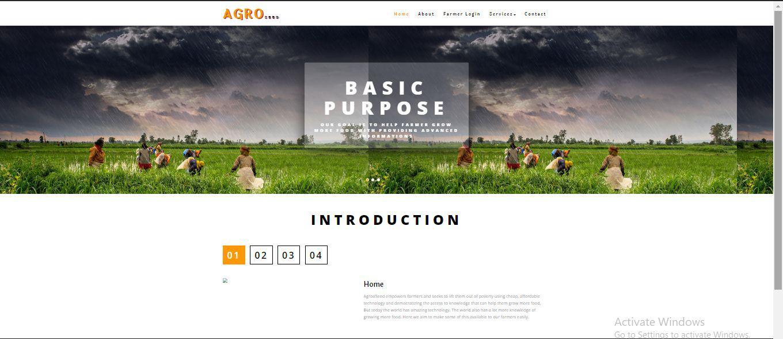

# PROJECT SCHEDULE & PLAN

The following project was started from the beginning of January 2020 and is completed by the end of April 2020.

|  |  |  |  |  |  |  |
| --- | --- | --- | --- | --- | --- | --- |
| Task | 4 jan-30 Jan | 31 Jan-9 Feb | 10 Feb-12 Mar | 13 Mar-16 Apr | 17 Apr-22 Apr | 23 Apr-28 Apr |
| Develop Project  Proposal | 27 Days |  |  |  |  |  |
| Analysis |  | 10 Days |  |  |  |  |
| Designing |  |  | 30 Days |  |  |  |
| Coding |  |  |  | 34 Days |  |  |
| Unit Testing |  |  |  |  | 5 Days |  |
| Implementation |  |  | .. |  |  | 5 Days |

# PROCESS DESCRIPTION

AgrooSeed is a website which will provide an easy access to farmers for all the information required for the crop development like soil description, crop description and type description to choose from best and apply best. Our system will also allow them to send messages for any other queries which are not there in the portal or which he is not able to access.

For Admin side he will be having full access to the registrations, messages and the website database information. He can add, view, and delete anything he wants. The admin is required to be pre-logged in to access everything.



### Product Perspective

**Purpose:**

Indian farmers are second to none in production and productivity despite of the fact that millions are marginal and small farmers. They adopt improved agriculture technology as efficiently as farmers in developed countries. It is felt that with provision of timely and adequate inputs such as fertilizers, seeds, pesticides and by making available affordable agricultural credit /crop insurance, Indian farmers are going to ensure food and nutritional security to the Nation. It is a website used for farmers for knowing the information about various crops, and in which soil they grow more, and the usage of fertilizers to the crops. If necessary, messaging system is also provided for them.

**Scope:**

○ providing accessibility to all users who have a valid user ID and password.

○ generating updated information regarding crops, types and soil for best output

○ User can message query and can get answers accordingly.

○ Phone numbers of the website managers are also given with the location of the nearest agriculture centre.

▪Users of the system: o Farmers

o Administrator

o Agricultural officers

**Features of the Site**

* Farmers can use the portal for getting the knowledge and guidance about which crop to grow according to soil and monsoon and all the important ingredients for best crop production like fertilizers, pesticides, water requirement etc.
* The information should not be accessed by an unauthorized person and only the admin can make all the changes required.
* In case of any queries the farmer can also contact the admin through messaging provided by portal itself.

This project is helpful in sharing secured information online at any time at any place and at any hour of the day being convenient. The user can sit at home and know all the useful information about his land and crop. It is being able to conduct business in all the 365 days.

**PROJECT IMPORTANCE**

An introduction to “The Farmer Portal”: In this project we will provide an easy access to farmers for all the information required for the crop development like soil description, crop description, type description to choose from best and apply best.

Our system will also allow them to send messages for any other queries which are not there in the portal or which he is not able to access.

Agriculture is the backbone of the Indian Economy"- said Mahatma Gandhi six decades ago. Even today, the situation is still the same, with almost the entire economy being sustained by agriculture, which is the mainstay of the villages. It contributes 16% of the overall GDP and accounts for employment of approximately 52% of the Indian population. Rapid growth in agriculture is essential not only for self-reliance but also to earn valuable foreign exchange.

Indian farmers are second to none in production and productivity despite of the fact that millions are marginal and small farmers. They adopt improved agriculture technology as efficiently as farmers in developed countries. It is felt that with provision of timely and adequate inputs such as fertilizers, seeds, pesticides and by making available affordable agricultural credit /crop insurance, Indian farmers are going to ensure food and nutritional security to the Nation.

Once logged in the Farmers’ Portal, a farmer will be able to get all relevant information on specific needs on land, crops etc. Nearest soil test center location can easily be reached through the Map of India placed on the Contact page. Farmers will also be able to ask specific queries as well as give valuable feedback through the message column.

**PROJECT ANALYSIS**

**EXISTING SYSTEM**

Complexity in managing and informing farmers about the data related to the agriculture products, soils, fertilizers, pesticides, crops, types and other details.

2.2.1 Problems in existing system:

● Lack of efficiency.

● This system does not provide category wise classifications of products.

● Inefficiency in querying details.

● Periodic Report generation takes a lot of time.

● Not accessible and known by all.

PROPOSED SYSTEM

AgrooSeed is a website which will provide an easy access to farmers for all the information required for the crop development like soil description, crop description and type description to choose from best and apply best. Our system will also allow them to send messages for any other queries which are not there in the portal or which he is not able to access.

For Admin side he will be having full access to the registrations, messages and the website database information. He can add, view, and delete anything he wants. The admin is required to be pre-logged in to access everything.

**REQUIREMENT SPECIFICATION:**

● Purpose:

Indian farmers are second to none in production and productivity despite of the fact that millions are marginal and small farmers. They adopt improved agriculture technology as efficiently as farmers in developed countries. It is felt that with provision of timely and adequate inputs such as fertilizers, seeds, pesticides and by making available affordable agricultural credit /crop insurance, Indian farmers are going to ensure food and nutritional security to the Nation. It is a website used for farmers for knowing the information about various crops, and in which soil they grow more, and the usage of fertilizers to the crops. If necessary, messaging system is also provided for them.

● Scope:

○Providing accessibility to all users who have a valid userID and password.

○Generating updated information regarding crops, types and soil for best output

○ User can message query and can get answers accordingly.

○ Phone numbers of the website managers are also given with the location of the nearest agriculture centre.

▪ Users of the system:

O Farmers

O Administrator

O Agricultural officers

**PRIMARY INVESTIGATION**

Data collection:

Early spring:

Beets, Broccoli, Brussels sprouts, Cabbage, Cauliflower, Carrots, Cress,

Lettuce, Onions, Peas, Potatoes, Radishes, Salad Greens, Spinach

Summer:

Beans, Butter Beans (Limas), Cantaloupe/Muskmelon, Corn,

Cowpeas/Crowder, Cucumbers, Eggplant, Garlic, Herbs, Okra, Peppers, Pumpkin, Soybeans, Squash, Sweet Potatoes, Tomatoes, Watermelon

Fall:

Beets, Broccoli, Brussels sprouts, Cabbage, Carrots, Cauliflower, Cress,

Lettuce, Peas, Radish, Salad Greens, Spinach, Turnips

Permanent Crops:

Asparagus, Blackberries, Blueberries, Grapes, Potato, Onions, Rhubarb,

Strawberries, Raspberries. Crops such as tomatoes and peppers will drop their blooms and it can even mess up a peppers ability to produce properly. If the leaves of beans get frost-bitten it can stun them and actually slow down their ability to grow properly.

N-P-K (Nitrogen-Phosphorus-Potassium) recommendations:

Nitrogen is a primary nutrient that really makes plants "grow." When you put fertilizer on your lawn, most of the "green-up and grow" comes from the nitrogen.

There are 'quick release' and 'slow release' forms of nitrogen. Slow release forms are more expensive but remain effective for a longer period of time. Organic fertilizers are slow release, and have less potential to "burn" plants.

Nitrogen produces vegetative growth in plants, but too much nitrogen can cause problems. One problem is succulent growth, which makes a plant more susceptible to certain diseases.78% of our atmosphere is nitrogen, and rain and snow account for 2 to 12 pounds of actual nitrogen per acre (43,560 square feet), per year.

"Lightning charged rain" is high in NH4 and NO3. Snow has been called "poor man's manure". . . now you know why!

Plants in the Legume family "fix" atmospheric nitrogen into the soil. Peas, beans, clover, and alfalfa are legumes, as well as Black Locust trees.

PHOSPHORUS (P) - the Phosphorus percentage is the middle number on the label

Example: 10-10-10

Phosphorus is a primary nutrient that encourages rooting, blooming and fruit production in plants.

Vegetable gardeners have typically been told to apply 5-10-5 since the higher middle number (P) helps vegetable production.

Phosphorus is important for root-growth and blooming in plants, and is the main ingredient in "starter fertilizers" as well as liquid fertilizer "bloom boosters".

Phosphorus is lacking in most Southwestern Pennsylvania soils we have tested since 1979. Applications of super-phosphate 20-0), triple super-phosphate (0-46-0), or bone meal (organic source) can be used to correct deficiencies.

Since phosphorus moves very slowly through the soil, it should be incorporated into the soil prior to, or during planting. In existing lawns, we recommend core-aeration prior to phosphorus application.

POTASSIUM (K) - the Potassium percentage is last on the label

Example: 10-10-10

Potassium helps plants resist disease and aids in winter hardiness ("K" is the symbol for "kalium" or potash, and is commonly used to represent potassium) Most 'winterizer' fertilizers used on lawns in late fall are high in Potassium, since it promotes winter hardiness in turfgrasses. Potassium fertilizers have a high "salt index" and should be used with caution, since they can "burn" plant foliage.

Most "complete" fertilizers contain potassium since it is fairly mobile, and readily leaches out of the soil profile.

**Information about Soils:**

**Sandy soil:**

All root vegetables like carrots, turnip, beetroot, coconut, and cashew also grow.

**Red Soil:**

Found in states of AP, Tamilnadu, Orissa, goa, Maharashtra, Karnataka. Red soil has iron content and is fit for crops like redgram, bengal-gram, groundnut and castorseed, millets, rice, maize, soyabean, pigeonpea, jute, tea, grapes, banana, papaya and mango, cashew.

**Black soil:**

Black soil is rich in potassium, calcium and magnesium crops like cotton, tobacco, chilly, oilseeds, jowar, ragi and maize grow covers an area of about 74 million.

Suitable for cotton crop other crops are potato, groundnut, sugarcane, soya-bean and wheat.

**Alluvial soil:**

Covers about 75 million acres and distributed in states of Punjab, Haryana,

Uttaranchal, Bihar, West Bengal, Uttarpradesh. Crops grow in it are rice, wheat, mustard, jute, sunflower, tomato, maize.

**Desert soil:**

Cover an area of about 29 million acres. millets, fooder, pulses are the main crops.

**Peaty and Marshy soils:**

Found in kerala, Orissa, Tamilnadu, West Bengal. These soils often produce a very good rice crop.

**Modular Design**

**1) USER SERVICES:**

This Module is main where user can access information and details like the soil details, crop details and type details as made in table form according to the required search from dropdown menu available.

**2) USER REGISTRATION:**

It allows Non user to register for sending and Receiving Information in a secure manner.

**3) USER LOGIN AND AUTHENTICATION:**

It allows User to Login in User Panel and authenticate to the non-users from Login. No user can access services provided without logging in.

**4) CONTACT FORM:**

**It allows User to contact regarding any query even without registration.**

**5) ADMINISTRATOR LOGIN AND AUTHENTICATION:**

It allows Administrator to Login in Admin Panel and authenticate to the users from Login.

**6) VIEW, UPDATE AND DELETE REGISTRATION:**

It is where admin can view, update and delete registrations of users.

**7) VIEW, UPDATE AND DELETE WEBSITE DATA:**

It allows admin to modify the website database and keep updating it whenever he wants

by specific forms of update information and add information.

**8) VIEW MESSAGES:**

It is used to view the messages sent by users by contact form and reply them through mail or call accordingly as required.

**MODULE DESCRIPTION**

It is quite difficult to do anything of its whole part at a time .So it is the task of the programmer to break/split the whole set of tasks into various small module so that one can handle them effectively. This project developed for “Farmer portal” is broken into following module.

**1. ADMIN MODULE**

Admin module is mainly for the owner of these system. This module performs the work of regular checking process. Everyone needs current information about anything. So, this module is responsible for updating the information continuously if any, in the system so that one can find timely information. But the main function of this module is to handle security of this system. Different types of authentication and authorization process is performed for this purpose.

**2. USER MODULE**

User page module is for front page of this system. It is the main page of the system in which all the links of this system like user registration, login, services, contact form, home page and about the website are kept. Now the main thing is how to make the home page interactive and user friendly so that there should not be any problem for the user. This is the task of the system administrator to make the home page Interactive.

**SYSTEM ANALYSIS**

**Feasibility Study**

**Operational Feasibility:**

By feasibility study we mean study of the current operational systems and brief consideration of alternative methods computerizing these tasks. The purpose of the feasibility study is to investigate the present system, evaluate the possible application of computer-based methods, select a tentative system, evaluate the cost and effectiveness of the proposed system, evaluate the impact of the proposed system on existing personal and ascertain the need for new personnel.

From the user point of view, a **Agroseed** here is easy to operate because it only uses simply step to by step to perform any task. The website simple for all user. So it no needs to give any instruction how to use these systems. There is no need to learn any special command and training to use this system.

**Technical Feasibility:**

Technical feasibility refers to the ability of the process to take advantages of the current state of the technology in pursuing further improvement. The front end tool proposed is easily compatible with the current hardware configuration in the organization. The back end tool proposed has the capacity to hold the data required for using the new system.

**Agroseed** uses the existing technology only. It uses internet for sending link of new register user and forgot password. Now a day these technologies are improved day by day. So it’s convenient to us use these technology. So there is no need to develop any hardware to provide these facilities. **Agroseed** is run on online shopping system which is available in most of devices. So there is no need to install any software or driver to run this website.

**Economic Feasibility:**

For declaring that the system is economically feasible, system will be cost effective and budgetary constraints, it should be cheap and quick. There isn’t any extra requirement of peripheral or software for development of system as it can be completed with the available resource.

**LIFE CYCLE MODELS**

The stage of planning the development process involves defining a define, develop, test, deliver, operate, and maintain a software product. Different lifecycle models emphasize different aspects of the lifecycle and no single lifecycle model is suitable for all software products. A lifecycle model that is understood and accepted by all concerned parties improves project communication and enhances project manageability, resource allocation, cost control, and product quality.

**The Phased Life Cycle Model**

The phased lifecycle model represents software lifecycle as a series of successive activities. Each phase requires well-defined input information, utilizes well-defined processes and results in well-defined products. The phased model consists of following phases.

Analysis, Design, Implementation, System Testing and Maintenance

This model is sometimes called the Waterfall Chart, the implication being that the products cascade from one level to another in smooth progression.

**Analysis Design**

**Implementation System Testing Maintenance**

**Planning,**

**User needs**

**Definition**

**Design**

**Details**

**Code, debug and Test**

**Integration & Acceptance**

**Enhance, Fix Adapt**

The Analysis Stage consists of Planning and Requirements definition Major include understanding the customer’s problem, performing A feasibility study, developing a recommended solution strategy, determining the acceptance criteria and planning development process. The products of planning are a System definition and a project plan.

The Software Design follows analysis. Design is concerned with its software components, specifying relationships among components specifying some structure, maintaining a record of design decisions and providing blueprint implementation phase. Design consists of detailed design and Architectural design.

The implementation phase of software development involves translation design specification into source code, and debugging, documentation and unit testing the source code. To enhance the quality of the software the methods are structured control constructs, built in and user defined data types, secure type checking, flexible scope rules exception handling mechanism, concurrency constructs and separates compilation modules.

System Testing involves two kinds of testing integration testing and acceptance testing. Developing a strategy for integrating the components of a software system into a functioning whole requires careful planning so that modules are available for integration when needed. Acceptance testing involves planning and execution of various tests in order to demonstrate that the implemented system satisfies the requirements document.

The Maintenance phase comes after the acceptance by the customer and release of the system for production work. Maintenance activities include enhancements of capabilities, adaptation of software to new processing environments, and correction of software bugs.

This project follows the Phased Life Cycle Model or the Water Fall model to a large extent.

The analysis stage consisted of listening to the needs and requirements of all departments obtaining the required format of the system as desired by them, taking the required data to be stored for future use etc., In the design stage the structure of the system was designed and all the required screens were formatted. This was then shown to the medical officer’s approval and the system was built. Implementation phase was also done at as they provided a computer with all the required software and with required configuration. The coding and debugging was done even after this stage certain changes were made as made as requested by the guide. The testing was done to check for any errors or bugs or unwanted behavior in the system. Individual modules as well as the whole system were tested separately.

**SOFTWARE TESTING**

Software Testing is a critical element of software quality assurance and represents the ultimate review of specification, design and coding, Testing presents an interesting anomaly for the software engineer.

Testing Objectives include:

1. Testing is a process of executing a program with the intent of finding an error

2. A good test case is one that has a probability of finding an as yet undiscovered error

3. A successful test is one that uncovers an undiscovered error

**Testing Principles:**

• All tests should be traceable to end user requirements

• Tests should be planned long before testing begins

• Testing should begin on a small scale and progress towards testing in large

• Exhaustive testing is not possible

• To be most effective testing should be conducted by a independent third party

**TESTING STRATERGIES**

A Strategy for software testing integrates software test cases into a series of well-planned steps that result in the successful construction of software. Software testing is a broader topic for what is referred to as Verification and Validation. Verification refers to the set of activities that ensure that the software correctly implements a specific function Validation refers he set of activities that ensure that the software that has been built is traceable to customer’s requirements

**Unit Testing:**

Unit testing focuses verification effort on the smallest unit of software design that is the module. Using procedural design description as a guide, important control paths are tested to uncover errors within the boundaries of the module. The unit test is normally white box testing oriented and the step can be conducted in parallel for multiple modules.

**Integration Testing:**

Integration testing is a systematic technique for constructing the program structure while conducting test to uncover errors associated with the interfacing. The objective is to take unit tested methods and build a program structure that has been dictated by design.

**Top-down Integration:**

Top down integrations an incremental approach to construction of program structure. Modules are integrated by moving downward through the control hierarchy, beginning with the main control program. Modules subordinate to the main program are incorporated in the structure either in the breath-first or depth-first manner.

**Bottom-up Integration:**

This method as the name suggests, begins construction and testing with atomic modules i.e., modules at the lowest leveling the program structure. Because the modules are integrated in the bottom up manner the processing required for the modules subordinate to a given level is always available and the need for stubs is eliminated.

**Validation Testing:**

At the end of integration testing software ids completely assembled as a package. Validation testing is the next stage which can be defined as successful when the software functions in the manner reasonably expected by the customer. Reasonable expectations are those defined in the software requirements specifications. Information contained in those sections form a basis for validation testing approach.

**System Testing:**

System testing is actually a series of different tests whose primary purpose is to fully exercise the computer-based system. Although each test has a different purpose, all work to verify that all system elements have been properly integrated to perform allocated functions.

**Recovery Testing:**

It is a system test that forces the system to fail in a variety of ways and verities that the recovery is properly performed.

**Security Testing:**

Attempts to verify the protection mechanisms built into the system.

**Performance Testing:**

This method is designed to test runtime performance of software within the context of an integrated system..Software testing is a critical element of software quality assurance and represents the ultimate review of specification, design and coding. Testing is the exposure of the system to trial input to see whether it produces correct output.

**Testing Phases:**

Software testing phases include the following:

Test activities are determined and test data selected.

The test is conducted and test results are compared with the expected results.

There are various types of Testing:

**Unit Testing:**

Unit testing is essentially for the verification of the code produced during the coding phase and the goal is test the internal logic of the module/program.

This project is thoroughly tested by exposing it to the various test cases regarding correct event generation, as this project passed all the tests its quality is completely assured.

**Integration Testing:**

All the tested modules are combined into sub systems, which are then tested. The goal is to see if the modules are properly integrated, and the emphasis being on the testing interfaces between the modules. On this project integration testing is done mainly while implementing menus in a sample application such as Browser for Mobiles.

**System Testing:**

It is mainly used if the software meets its requirements. The reference document for this process is the requirement document.

**Acceptance Testing:**

It is performed with realistic data of the client to demonstrate that the software is working satisfactorily.

**Testing Methods:**

Testing is a process of executing a program to find out errors. If testing is conducted successfully, it will uncover all the errors in the software. Any testing can be done basing on two ways:

**White Box Testing:**

It is a test case design method that uses the control structures of the procedural design to derive test cases. using this testing a software Engineer can derive the following test cases:

Exercise all the logical decisions on either true or false sides. Execute all loops at their boundaries and within their operational boundaries. Exercise the internal data structures to assure their validity.

**Black Box Testing:**

It is a test case design method used on the functional requirements of the software. It will help a software engineer to derive sets of input conditions that will exercise all the functional requirements of the program. Black Box testing attempts to find errors in the following categories:

Incorrect or missing functions

Interface errors

Errors in data structures

Performance errors

Initialization and termination errors

By Black Box Testing we derive a set of test cases that satisfy the following criteria:

Test cases that reduce by a count that is greater than one, the number of additional test cases that must be designed to achieve reasonable testing.

Test cases that tell us something about the presence or absence of classes of errors rather than errors associated only with a specific test at hand.

**Test Approach:**

Testing can be done in two ways:

Bottom up approach

Top down approach

**Bottom up Approach:**

Testing can be performed starting from smallest and lowest level modules and proceeding one at a time. For each module in bottom up testing a short program executes the module and provides the needed data so that the module is asked to perform the way it will when embedded within the larger system. When bottom level modules are tested attention turns to those on the next level that use the lower level ones they are tested individually and then linked with the previously examined lower level modules.

**Top down approach:**

This type of testing starts from upper level modules. Since the detailed activities usually performed in the lower level routines are not provided stubs are written. A stub is a module shell called by upper level module and that when reached properly will return a message to the calling module indicating that proper interaction occurred. No attempt is made to verify the correctness of the lower level module.

**Input and Output Forms:**

Input design is the link that ties the information system into the world of its Users. The input design involves determining the inputs, validating the data, minimizing the data entry and provides a multi-user facility. Inaccurate inputs are the most common cause of errors in data processing. Errors entered by the data entry operators can be controlled by input design.

The user-originated inputs are converted to a computer based format in the input design. Input data are collected and organized into groups of similar data. Once identified, the appropriate input media are selected for processing. All the input data are validated and if any data violates any conditions, the user is warned by a message.

If the data satisfies all the conditions, it is transferred to the appropriate tables in the database. In this project the student details are to be entered at the time of registration. A page is designed for this purpose which is user friendly and easy to use. The design is done such that users get appropriate messages when exceptions occur.

Computer output is the most important and direct source of information to the user. Output design is a very important phase since the output needs to be in an efficient manner. Efficient and intelligible output design improves the system relationship with the user and helps in decision making.

Allowing the user to view the sample screen is important because the user is the ultimate judge of the quality of output. The output module of this system is the selected notifications.

**Screenshots**

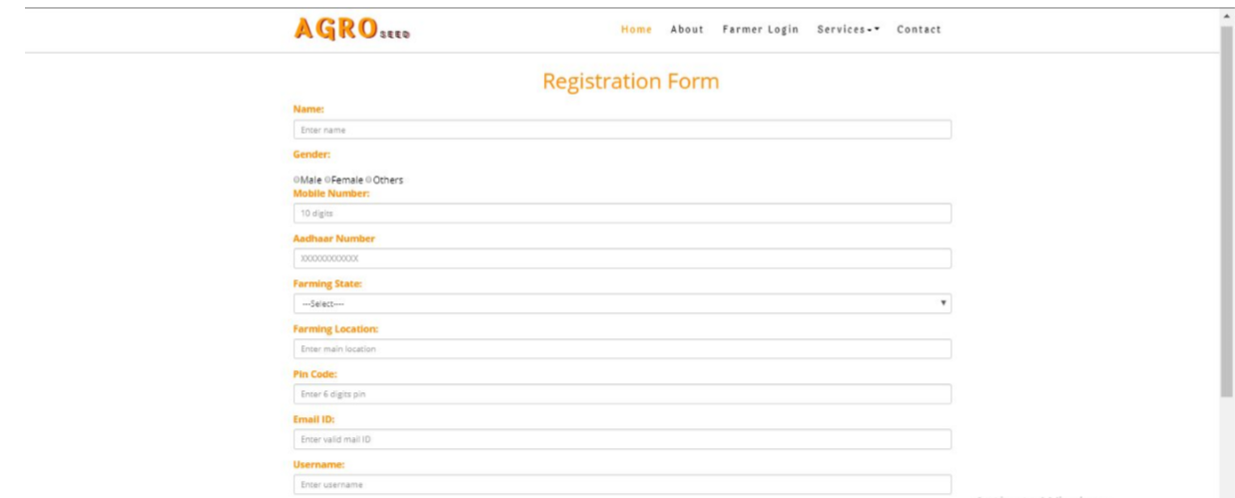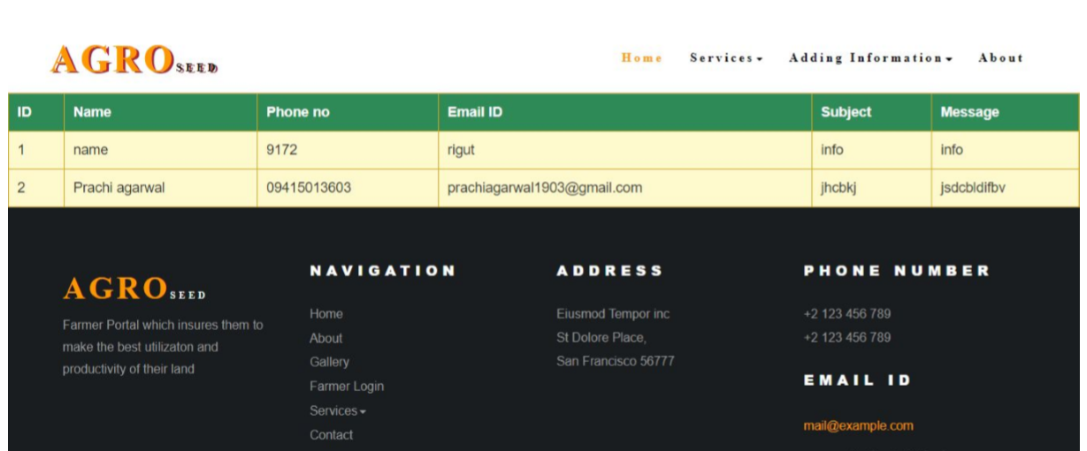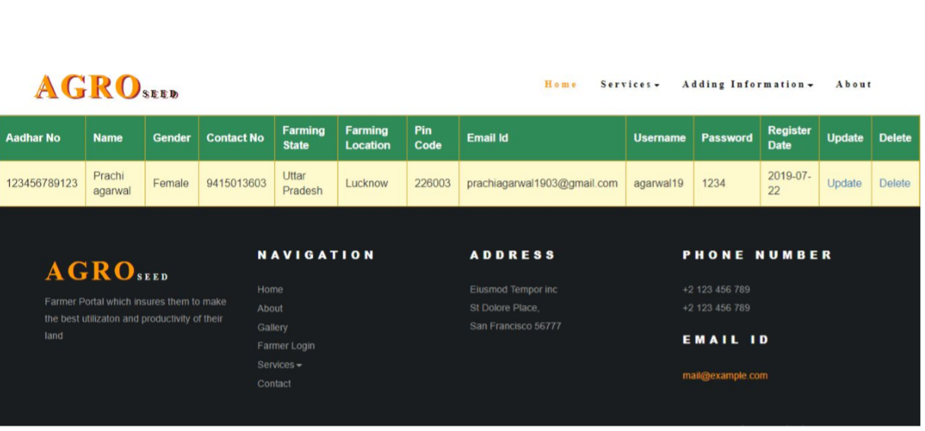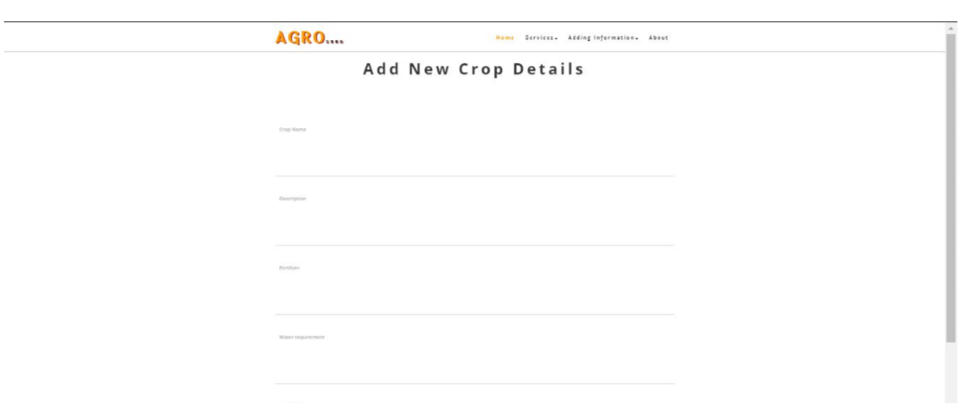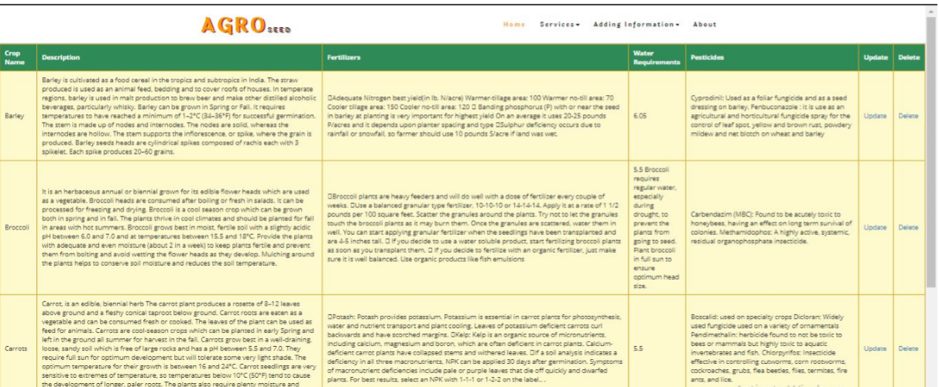

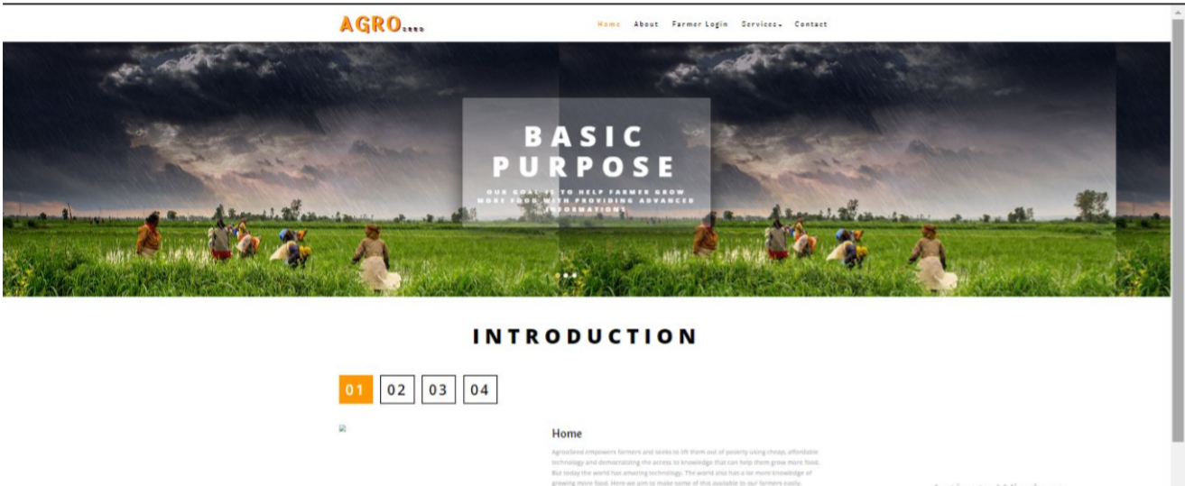

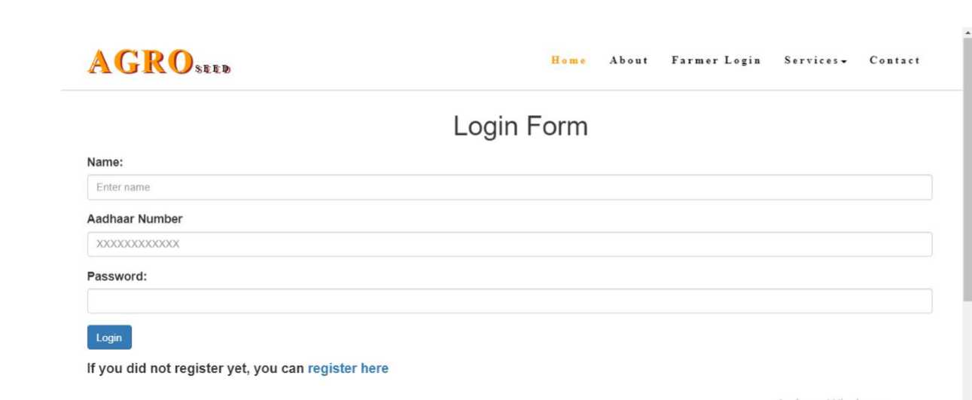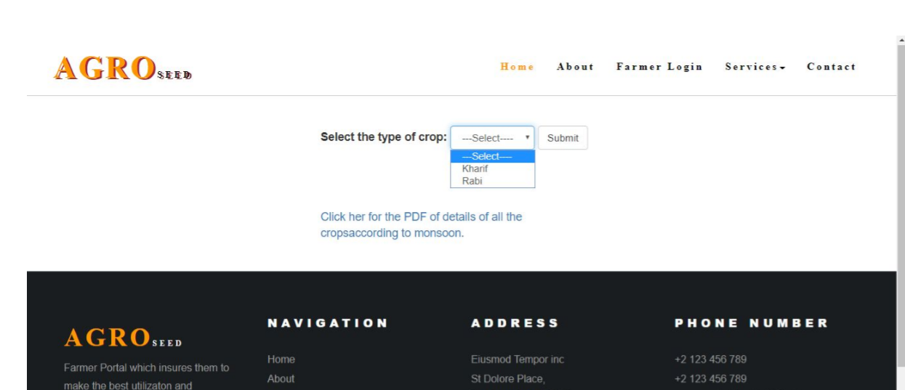

**UML Diagram**

**Use Case Diagram**

Register

Login

Soil Details

Crop Details

Admin

User

View, Update, Delete Registration

View, Update, Delete website data

View messages & Response

Send Messages

**Activity Diagram**

Start

Admin

User

**c**

End

**DFD**

Admin

User

Register

Register

Login

Soil Details

Crop Details

Login

Soil Details

View, Update, Delete Registration

View, Update, Delete website data

Send Messages

View messages & Response

**ER-Diagram**

Agroseed DB

Admin

User

Account

Account

Registration

Soil

Website Data

Crop

Message

**Coding Part**

**User Section**

**Contact Section**

<%@ page language="java" contentType="text/html; charset=ISO-8859-1"

pageEncoding="ISO-8859-1"%>

<!DOCTYPE html PUBLIC "-//W3C//DTD HTML 4.01 Transitional//EN" "http://www.w3.org/TR/html4/loose.dtd">

<html>

<head>

<meta http-equiv="Content-Type" content="text/html; charset=ISO-8859-1">

<title>Agro Seed an Agriculture Category Bootstrap responsive Website Template | Contact :: w3layouts</title>

<meta name="viewport" content="width=device-width, initial-scale=1">

<meta charset="utf-8">

<meta name="keywords" content="Agro Seed Responsive web template, Bootstrap Web Templates, Flat Web Templates, Android Compatible web template,

Smartphone Compatible web template, free webdesigns for Nokia, Samsung, LG, SonyEricsson, Motorola web design" />

<script type="application/x-javascript"> addEventListener("load", function() { setTimeout(hideURLbar, 0); }, false); function hideURLbar(){ window.scrollTo(0,1); } </script>

<!-- bootstrap-css -->

<link href="css/bootstrap.css" rel="stylesheet" type="text/css" media="all" />

<!--// bootstrap-css -->

<!-- css -->

<link rel="stylesheet" href="../css/style.css" type="text/css" media="all" />

<!--// css -->

<!-- font-awesome icons -->

<link href="../css/font-awesome.css" rel="stylesheet">

<!-- //font-awesome icons -->

<!-- font -->

<link href="http://fonts.googleapis.com/css?family=Laila:300,400,500,600,700" rel="stylesheet">

<link href="http://fonts.googleapis.com/css?family=Open+Sans:300,300i,400,400i,600,600i,700,700i,800,800i" rel="stylesheet">

<!-- //font -->

<script src="../js/jquery-1.11.1.min.js"></script>

<script src="../js/bootstrap.js"></script>

<script type="text/javascript">

jQuery(document).ready(function($) {

$(".scroll").click(function(event){

event.preventDefault();

$('html,body').animate({scrollTop:$(this.hash).offset().top},1000);

});

});

</script>

</head>

<body>

<%@ include file="Header1.jsp" %>

<!-- banner-slider -->

<div class="jarallax about-banner" style="padding: 1em 0">

<div class="container">

<div class="agileits-heading about-heading" style="font-weight:600px;">

<h2 >Contact</h2>

</div>

</div>

</div>

<!-- //banner-slider -->

<!-- //banner -->

<!---728x90--->

<!-- contact -->

<div class="contact" style="padding: 2em 0">

<div class="container">

<div class="map-grid">

<iframe src="https://www.google.com/maps/embed?pb=!1m18!1m12!1m3!1d3558.720470552181!2d80.93922731436503!3d26.880620767943597!2m3!1f0!2f0!3f0!3m2!1i1024!2i768!4f13.1!3m3!1m2!1s0x399bfd7fc2988c67%3A0x611387c72ea67a59!2sInfoseek+%7C+Brand+of+My5+Technologies+Pvt.+Ltd.!5e0!3m2!1sen!2sin!4v1560513825316!5m2!1sen!2sin" width="600" height="450" frameborder="0" style="border:0" class="map" allowfullscreen></iframe>

</div>

<!---728x90--->

<div class="address">

<div class="col-sm-4 address-grids">

<h4>Address :</h4>

<p>Eiusmod Tempor inc<br>

<span>St Dolore Place,</span>

San Francisco 56777

</p>

</div>

<div class="col-sm-4 address-grids">

<h4>Phone :</h4>

<p>+2 123 456 789</p>

<p>+2 987 654 321</p>

</div>

<div class="col-sm-4 address-grids">

<h4>Email :</h4>

<p><a href="mailto:example@email.com">mail@example.com</a></p>

</div>

<div class="clearfix"> </div>

</div>

<div class="contact-form">

<h4>Contact Form</h4>

<div class="contact-form-grid">

<form action="" method="post">

<div class="fields-grid">

<div class="styled-input agile-styled-input-top">

<input type="text" name="Name" required>

<label>Full Name</label>

<span></span>

</div>

<div class="styled-input agile-styled-input-top">

<input type="text" name="Phone" required>

<label>Phone</label>

<span></span>

</div>

<div class="styled-input">

<input type="text" name="Email" required>

<label>Email Id</label>

<span></span>

</div>

<div class="styled-input">

<input type="text" name="Subject" required>

<label>Subject</label>

<span></span>

</div>

<div class="clearfix"> </div>

</div>

<div class="styled-input textarea-grid">

<textarea name="Message" required></textarea>

<label>Message</label>

<span></span>

</div>

<input type="submit" value="SEND" name="send">

<%@ include file = "../Connection.jsp" %>

<%

try{

// String password = request.getParameter("pass"); -->

if(request.getParameter("send")!= null)

{

Statement st =cn.createStatement();

st.executeUpdate("insert into contact(name,phone,emailid,subject,message,ContactDate) values('"+request.getParameter("Name")+"','"+request.getParameter("Phone")+"','"+request.getParameter("Email")+"','"+request.getParameter("Subject")+"','"+request.getParameter("Message")+"',CURDATE())");

{

out.println("success");

}

}

}

catch(Exception ex)

{

out.println(ex);

}

%>

</form>

</div>

</div>

</div>

</div>

<!-- //contact -->

<!---728x90--->

<!-- footer -->

<%@ include file="footer.jsp" %>

<!-- //footer -->

<!-- copyright -->

<!-- //copyright -->

<script src="js/jarallax.js"></script>

<script src="js/SmoothScroll.min.js"></script>

<script type="text/javascript">

/* init Jarallax */

$('.jarallax').jarallax({

speed: 0.5,

imgWidth: 1366,

imgHeight: 768

})

</script>

<script type="text/javascript" src="js/move-top.js"></script>

<script type="text/javascript" src="js/easing.js"></script>

<!-- here stars scrolling icon -->

<script type="text/javascript">

$(document).ready(function() {

/*

var defaults = {

containerID: 'toTop', // fading element id

containerHoverID: 'toTopHover', // fading element hover id

scrollSpeed: 1200,

easingType: 'linear'

};

*/

$().UItoTop({ easingType: 'easeOutQuart' });

});

</script>

<!-- //here ends scrolling icon -->

</body>

</html>

**Crop Details**

<%@ page language="java" contentType="text/html; charset=ISO-8859-1"

pageEncoding="ISO-8859-1"%>

<!DOCTYPE html PUBLIC "-//W3C//DTD HTML 4.01 Transitional//EN" "http://www.w3.org/TR/html4/loose.dtd">

<html>

<head>

<meta http-equiv="Content-Type" content="text/html; charset=ISO-8859-1">

<title>Agro Seed an Agriculture Category Bootstrap responsive Website Template | Contact :: w3layouts</title>

<meta name="viewport" content="width=device-width, initial-scale=1">

<meta charset="utf-8">

<meta name="keywords" content="Agro Seed Responsive web template, Bootstrap Web Templates, Flat Web Templates, Android Compatible web template,

Smartphone Compatible web template, free webdesigns for Nokia, Samsung, LG, SonyEricsson, Motorola web design" />

<script type="application/x-javascript"> addEventListener("load", function() { setTimeout(hideURLbar, 0); }, false); function hideURLbar(){ window.scrollTo(0,1); } </script>

<!-- bootstrap-css -->

<link href="css/bootstrap.css" rel="stylesheet" type="text/css" media="all" />

<!--// bootstrap-css -->

<!-- css -->

<link rel="stylesheet" href="../css/style.css" type="text/css" media="all" />

<!--// css -->

<!-- font-awesome icons -->

<link href="../css/font-awesome.css" rel="stylesheet">

<!-- //font-awesome icons -->

<!-- font -->

<link href="http://fonts.googleapis.com/css?family=Laila:300,400,500,600,700" rel="stylesheet">

<link href="http://fonts.googleapis.com/css?family=Open+Sans:300,300i,400,400i,600,600i,700,700i,800,800i" rel="stylesheet">

<!-- //font -->

<script src="../js/jquery-1.11.1.min.js"></script>

<script src="../js/bootstrap.js"></script>

<script type="text/javascript">

jQuery(document).ready(function($) {

$(".scroll").click(function(event){

event.preventDefault();

$('html,body').animate({scrollTop:$(this.hash).offset().top},1000);

});

});

</script>

<style>

.a{

padding: 5ex 50ex;

}

#logo{

text-shadow: 3px 2px brown;

}

.myTable {

width: 100%;

text-align: left;

background-color: lemonchiffon;

border-collapse: collapse;

}

.myTable th {

background-color: seagreen;

color: white;

}

.myTable td,

.myTable th {

padding: 10px;

border: 1px solid goldenrod;

}

</style>

</head>

<body>

<%@include file="../Connection.jsp" %>

<%@include file="Header1.jsp" %>

<% if(session.getAttribute("Adhaar") == null){

response.getWriter().append("Login first to access services");

response.sendRedirect("login.jsp");

}

else {

%>

<div class="a">

<form class="form-inline" action="" >

<div class="form-group">

<label for="type">Select crop name:</label>

<select name="type" id="type" class="form-control" required>

<%

Statement st= cn.createStatement();

ResultSet rs= st.executeQuery("select * from crop");

%>

<option value="null">---Select---- </option>

<%

while(rs.next())

{

%>

<option value=<%=rs.getInt(1) %>><%=rs.getString(2)%></option>

<%

}%>

</select>

</div>

<button type="submit" name="submit" class="btn btn-default">Search</button>

</form>

</div>

<div>

<%

try

{

if(request.getParameter("submit")!=null)

{

%>

<table class="myTable" style="padding-bottom:30px;">

<tbody>

<tr>

<th>Crop Name</th>

<th>Description</th>

<th>Fertilizers</th>

<th>Water requirement</th>

<th>Pesticides</th>

</tr>

</tbody>

<%

//Statement st= cn.createStatement();

rs= st.executeQuery("select * from crop where Id='"+request.getParameter("type")+"' and Status="+1);

while(rs.next())

{

%>

<tr>

<td><%= rs.getString("Crop") %></td>

<td><%= rs.getString("Description") %></td>

<td><%= rs.getString("Fertilizers") %></td>

<td><%= rs.getString("Water") %></td>

<td><%= rs.getString("Pesticides") %></td>

</tr>

<%

}

%>

</table>

<%

{

out.println("");

}

}

}catch(Exception ex)

{

out.println(ex);

}

%>

</div>

<div class="a">

<a href ="../PDF/Crop table-converted.pdf">Click her for the PDF of details of all the crops.</a>

</div>

<%@ include file="footer.jsp" %>

<script>

// Disable form submissions if there are invalid fields

(function() {

'use strict';

window.addEventListener('load', function() {

// Get the forms we want to add validation styles to

var forms = document.getElementsByClassName('needs-validation');

// Loop over them and prevent submission

var validation = Array.prototype.filter.call(forms, function(form) {

form.addEventListener('submit', function(event) {

if (form.checkValidity() === false) {

event.preventDefault();

event.stopPropagation();

}

form.classList.add('was-validated');

}, false);

});

}, false);

})();

</script>

<%

}%>

</body>

</html>

**Land Details**

<%@ page language="java" contentType="text/html; charset=ISO-8859-1"

pageEncoding="ISO-8859-1"%>

<!DOCTYPE html PUBLIC "-//W3C//DTD HTML 4.01 Transitional//EN" "http://www.w3.org/TR/html4/loose.dtd">

<html>

<head>

<meta http-equiv="Content-Type" content="text/html; charset=ISO-8859-1">

<title>Agro Seed an Agriculture Category Bootstrap responsive Website Template | Contact :: w3layouts</title>

<meta name="viewport" content="width=device-width, initial-scale=1">

<meta charset="utf-8">

<meta name="keywords" content="Agro Seed Responsive web template, Bootstrap Web Templates, Flat Web Templates, Android Compatible web template,

Smartphone Compatible web template, free webdesigns for Nokia, Samsung, LG, SonyEricsson, Motorola web design" />

<script type="application/x-javascript"> addEventListener("load", function() { setTimeout(hideURLbar, 0); }, false); function hideURLbar(){ window.scrollTo(0,1); } </script>

<!-- bootstrap-css -->

<link href="css/bootstrap.css" rel="stylesheet" type="text/css" media="all" />

<!--// bootstrap-css -->

<!-- css -->

<link rel="stylesheet" href="../css/style.css" type="text/css" media="all" />

<!--// css -->

<!-- font-awesome icons -->

<link href="../css/font-awesome.css" rel="stylesheet">

<!-- //font-awesome icons -->

<!-- font -->

<link href="http://fonts.googleapis.com/css?family=Laila:300,400,500,600,700" rel="stylesheet">

<link href="http://fonts.googleapis.com/css?family=Open+Sans:300,300i,400,400i,600,600i,700,700i,800,800i" rel="stylesheet">

<!-- //font -->

<script src="../js/jquery-1.11.1.min.js"></script>

<script src="../js/bootstrap.js"></script>

<script type="text/javascript">

jQuery(document).ready(function($) {

$(".scroll").click(function(event){

event.preventDefault();

$('html,body').animate({scrollTop:$(this.hash).offset().top},1000);

});

});

</script>

<style>

.a{

padding: 5ex 50ex;

}

#logo{

text-shadow: 3px 2px brown;

}

.myTable {

width: 100%;

text-align: left;

background-color: lemonchiffon;

border-collapse: collapse;

}

.myTable th {

background-color: seagreen;

color: white;

}

.myTable td,

.myTable th {

padding: 10px;

border: 1px solid goldenrod;

}

</style>

</head>

<body>

<%@include file="../Connection.jsp" %>

<%@include file="Header1.jsp" %>

<% if(session.getAttribute("Adhaar") == null){

response.getWriter().append("Login first to access services");

response.sendRedirect("login.jsp");

}

else {

%>

<div class="a">

<form class="form-inline" action="" >

<div class="form-group">

<label for="type">Select the type of soil:</label>

<select name="type" id="type" class="form-control" required>

<%

Statement st= cn.createStatement();

ResultSet rs= st.executeQuery("select * from soil");

%>

<option value="null">---Select---- </option>

<%

while(rs.next())

{

%>

<option value=<%=rs.getInt(1) %>><%=rs.getString(2)%></option>

<%

}%>

</select>

</div>

<button type="submit" name="submit" class="btn btn-default">Search</button>

</form>

</div>

<div>

<%

try

{

if(request.getParameter("submit")!=null)

{

%>

<table class="myTable" style="padding-bottom:30px;">

<tbody>

<tr>

<th>Soil Type</th>

<th>Description</th>

<th>Crops Name</th>

</tr>

</tbody>

<%

// Statement st= cn.createStatement();

rs= st.executeQuery("select * from soil where Id='"+request.getParameter("type")+"' and Status="+1);

while(rs.next())

{

%>

<tr>

<td><%= rs.getString("Name") %></td>

<td><%= rs.getString("Description") %></td>

<td><%= rs.getString("Crops") %></td>

</tr>

<%

}

%>

</table>

<%

{

out.println("");

}

}

}catch(Exception ex)

{

out.println(ex);

}

%>

</div>

<div class="a">

<a href ="../PDF/Soil table-converted (1).pdf">Click here for the PDF containing all the soils details along with monsoon crops.</a>

</div>

<%@ include file="footer.jsp" %>

<script>

// Disable form submissions if there are invalid fields

(function() {

'use strict';

window.addEventListener('load', function() {

// Get the forms we want to add validation styles to

var forms = document.getElementsByClassName('needs-validation');

// Loop over them and prevent submission

var validation = Array.prototype.filter.call(forms, function(form) {

form.addEventListener('submit', function(event) {

if (form.checkValidity() === false) {

event.preventDefault();

event.stopPropagation();

}

form.classList.add('was-validated');

}, false);

});

}, false);

})();

</script>

<%

}%>

</body>

</html>

**Login**

<%@ page language="java" contentType="text/html; charset=ISO-8859-1"

pageEncoding="ISO-8859-1"%>

<!DOCTYPE html PUBLIC "-//W3C//DTD HTML 4.01 Transitional//EN" "http://www.w3.org/TR/html4/loose.dtd">

<html>

<head>

<meta http-equiv="Content-Type" content="text/html; charset=ISO-8859-1">

<title>Insert title here</title>

<meta charset="utf-8">

<meta name="viewport" content="width=device-width, initial-scale=1">

<meta charset="utf-8">

<meta name="keywords" content="Agro Seed Responsive web template, Bootstrap Web Templates, Flat Web Templates, Android Compatible web template,

Smartphone Compatible web template, free webdesigns for Nokia, Samsung, LG, SonyEricsson, Motorola web design" />

<script type="application/x-javascript"> addEventListener("load", function() { setTimeout(hideURLbar, 0); }, false); function hideURLbar(){ window.scrollTo(0,1); } </script>

<!-- bootstrap-css -->

<link href="css/bootstrap.css" rel="stylesheet" type="text/css" media="all" />

<!--// bootstrap-css -->

<!-- css -->

<link rel="stylesheet" href="../css/style.css" type="text/css" media="all" />

<!--// css -->

<!-- font-awesome icons -->

<link href="../css/font-awesome.css" rel="stylesheet">

<!-- //font-awesome icons -->

<!-- font -->

<link href="http://fonts.googleapis.com/css?family=Laila:300,400,500,600,700" rel="stylesheet">

<link href="http://fonts.googleapis.com/css?family=Open+Sans:300,300i,400,400i,600,600i,700,700i,800,800i" rel="stylesheet">

<!-- //font -->

<script src="../js/jquery-1.11.1.min.js"></script>

<script src="../js/bootstrap.js"></script>

<script type="text/javascript">

jQuery(document).ready(function($) {

$(".scroll").click(function(event){

event.preventDefault();

$('html,body').animate({scrollTop:$(this.hash).offset().top},1000);

});

});

</script>

</head>

<body>

<%@page import="java.io.*" %>

<%@page import="java.sql.*" %>

<%@page import="javax.sql.*" %>

<%@page import="java.sql.Connection" %>

<%@ include file="../Connection.jsp" %>

<%@include file="Header1.jsp" %>

<div class="container" style="padding-bottom:35px">

<div class="jarallax about-banner" style="padding: .5em 0">

<div class="container">

<div class="agileits-heading about-heading">

<h1>Login Form</h1>

</div>

</div>

</div>

<form action="" class="needs-validation" novalidate>

<div class="form-group">

<label for="uname">Name:</label>

<input type="text" class="form-control" id="name" placeholder="Enter name" name="name" required>

</div>

<div class="form-group">

<label for="uname">Aadhaar Number</label>

<input type="tel" class="form-control" id="adhaar" placeholder="XXXXXXXXXXXX" name="adhaar" maxlength="12" pattern=[0-9]{12,12} required>

</div>

<div class="form-group">

<label for="uname">Password:</label>

<input type="password" class="form-control" name="pass" required>

</div>

<button type="submit" class="btn btn-primary" name="Login">Login</button>

<%

try{

if(request.getParameter("Login")!= null){

Statement st1 =cn.createStatement();

ResultSet rs =st1.executeQuery("select * from registration where Aadhaar='"+request.getParameter("adhaar")+"' and Password='"+request.getParameter("pass")+"'");

if(rs.next())

{

session.setAttribute("Adhaar",request.getParameter("adhaar"));

out.println("You are loged in Successfully ! ");

}else

{

PrintWriter outa = response.getWriter();

out.println("<script type=\"text/javascript\">");

out.println("alert('Invalid Information ');");

out.println("location='login.jsp';");

out.println("</script>");

}

}

}catch(Exception ex)

{

out.println(ex);

}

%>

</form>

<form action="register.jsp">

<h4> <p style="margin:16px 0 10px ;font-weight:600">If you did not register yet, you can <a href="register.jsp">register here</a></p></h4>

</form>

</div>

<%@ include file="footer.jsp" %>

<script>

// Disable form submissions if there are invalid fields

(function() {

'use strict';

window.addEventListener('load', function() {

// Get the forms we want to add validation styles to

var forms = document.getElementsByClassName('needs-validation');

// Loop over them and prevent submission

var validation = Array.prototype.filter.call(forms, function(form) {

form.addEventListener('submit', function(event) {

if (form.checkValidity() === false) {

event.preventDefault();

event.stopPropagation();

}

form.classList.add('was-validated');

}, false);

});

}, false);

})();

</script>

</body>

</html>

**Monsoon Details**

<%@ page language="java" contentType="text/html; charset=ISO-8859-1"

pageEncoding="ISO-8859-1"%>

<!DOCTYPE html PUBLIC "-//W3C//DTD HTML 4.01 Transitional//EN" "http://www.w3.org/TR/html4/loose.dtd">

<html>

<head>

<meta http-equiv="Content-Type" content="text/html; charset=ISO-8859-1">

<title>Agro Seed an Agriculture Category Bootstrap responsive Website Template | Contact :: w3layouts</title>

<meta name="viewport" content="width=device-width, initial-scale=1">

<meta charset="utf-8">

<meta name="keywords" content="Agro Seed Responsive web template, Bootstrap Web Templates, Flat Web Templates, Android Compatible web template,

Smartphone Compatible web template, free webdesigns for Nokia, Samsung, LG, SonyEricsson, Motorola web design" />

<script type="application/x-javascript"> addEventListener("load", function() { setTimeout(hideURLbar, 0); }, false); function hideURLbar(){ window.scrollTo(0,1); } </script>

<!-- bootstrap-css -->

<link href="css/bootstrap.css" rel="stylesheet" type="text/css" media="all" />

<!--// bootstrap-css -->

<!-- css -->

<link rel="stylesheet" href="../css/style.css" type="text/css" media="all" />

<!--// css -->

<!-- font-awesome icons -->

<link href="../css/font-awesome.css" rel="stylesheet">

<!-- //font-awesome icons -->

<!-- font -->

<link href="http://fonts.googleapis.com/css?family=Laila:300,400,500,600,700" rel="stylesheet">

<link href="http://fonts.googleapis.com/css?family=Open+Sans:300,300i,400,400i,600,600i,700,700i,800,800i" rel="stylesheet">

<!-- //font -->

<script src="../js/jquery-1.11.1.min.js"></script>

<script src="../js/bootstrap.js"></script>

<script type="text/javascript">

jQuery(document).ready(function($) {

$(".scroll").click(function(event){

event.preventDefault();

$('html,body').animate({scrollTop:$(this.hash).offset().top},1000);

});

});

</script>

<style>

.a{

padding: 5ex 50ex;

}

#logo{

text-shadow: 3px 2px brown;

}

.myTable {

width: 100%;

text-align: left;

background-color: lemonchiffon;

border-collapse: collapse;

}

.myTable th {

background-color: seagreen;

color: white;

}

.myTable td,

.myTable th {

padding: 10px;

border: 1px solid goldenrod;

}

</style>

</head>

<body>

<%@include file="../Connection.jsp" %>

<%@include file="Header1.jsp" %>

<% if(session.getAttribute("Adhaar") == null){

response.getWriter().append("Login first to access services");

response.sendRedirect("login.jsp");

}

else {

%>

<div class="a">

<form class="form-inline" action="" >

<div class="form-group">

<label for="type">Select the type of crop:</label>

<select name="type" id="type" class="form-control" required>

<%

Statement st= cn.createStatement();

ResultSet rs= st.executeQuery("select * from monsoon");

%>

<option value="null">---Select---- </option>

<%

while(rs.next())

{

%>

<option value=<%=rs.getInt(1) %>><%=rs.getString(2)%></option>

<%

}%>

</select>

</div>

<button type="submit" name="submit" class="btn btn-default">Submit</button>

</form>

</div>

<div>

<%

try

{

if(request.getParameter("submit")!=null)

{

%>

<table class="myTable" style="padding-bottom:30px;">

<tbody>

<tr>

<th>Crop Type</th>

<th>Description</th>

<th>Sown Time</th>

<th>Harvest Time</th>

<th>Crops Name</th>

</tr>

</tbody>

<%

rs= st.executeQuery("select * from monsoon where Id='"+request.getParameter("type")+"' and Status="+1);

while(rs.next())

{

%>

<tr>

<td><%= rs.getString("Type") %></td>

<td><%= rs.getString("Description") %></td>

<td><%= rs.getString("Sown") %></td>

<td><%= rs.getString("Harvest") %></td>

<td><%= rs.getString("Crops") %></td>

</tr>

<%

}

%>

</table>

<%

{

out.println("");

}

}

}catch(Exception ex)

{

out.println(ex);

}

%>

</div>

<div class="a">

<a href ="../PDF/monsoon table-converted.pdf">Click her for the PDF of details of all the cropsaccording to monsoon.</a>

</div>

<%@ include file="footer.jsp" %>

<script>

// Disable form submissions if there are invalid fields

(function() {

'use strict';

window.addEventListener('load', function() {

// Get the forms we want to add validation styles to

var forms = document.getElementsByClassName('needs-validation');

// Loop over them and prevent submission

var validation = Array.prototype.filter.call(forms, function(form) {

form.addEventListener('submit', function(event) {

if (form.checkValidity() === false) {

event.preventDefault();

event.stopPropagation();

}

form.classList.add('was-validated');

}, false);

});

}, false);

})();

</script>

<%

}%>

</body>

</html>

**Register**

<%@ page language="java" contentType="text/html; charset=ISO-8859-1"

pageEncoding="ISO-8859-1"%>

<!DOCTYPE html PUBLIC "-//W3C//DTD HTML 4.01 Transitional//EN" "http://www.w3.org/TR/html4/loose.dtd">

<html>

<head>

<meta http-equiv="Content-Type" content="text/html; charset=ISO-8859-1">

<title>Insert title here</title>

<meta charset="utf-8">

<meta name="viewport" content="width=device-width, initial-scale=1">

<link rel="stylesheet" href="https://maxcdn.bootstrapcdn.com/bootstrap/4.3.1/css/bootstrap.min.css">

<script src="https://ajax.googleapis.com/ajax/libs/jquery/3.4.0/jquery.min.js"></script>

<script src="https://cdnjs.cloudflare.com/ajax/libs/popper.js/1.14.7/umd/popper.min.js"></script>

<script src="https://maxcdn.bootstrapcdn.com/bootstrap/4.3.1/js/bootstrap.min.js"></script>

</head>

<style>

.form-group{

background-color: white;}

.navbar-nav{

flex-direction: unset;

}

.about-banner {

padding: 0em 0;

}

</style>

<body style="color: darkorange;">

<%@include file="../Connection.jsp" %>

<%@include file="Header1.jsp" %>

<div class="container" style="padding-bottom: 25px;">

<div class="jarallax about-banner" style="padding: .5em 0">

<div class="container">

<div class="agileits-heading about-heading" >

<h1>Registration Form</h1>

</div>

</div>

</div>

<form action="" class="needs-validation" novalidate>

<div class="form-group">

<label for="uname">Name:</label>

<input type="text" class="form-control" id="name" placeholder="Enter name" name="name" required>

<div class="valid-feedback">Valid.</div>

<div class="invalid-feedback">Please fill out this field.</div>

</div>

<div class="form-group">

<label for="gender" >Gender:</label><br/></div>

<div style="color: black;">

<input type="radio" id="gender" name="gender" value="Male" required>Male

<input type="radio" id="gender" name="gender" value="Female" required>Female

<input type="radio" id="gender" name="gender" value="Others" required>Others

</div>

<div class="form-group">

<label for="uname">Mobile Number:</label>

<input type="tel" class="form-control" id="mobno" placeholder="10 digits" name="mobno" pattern="[0-9]{10}" maxlength="10" required>

<div class="valid-feedback">Valid.</div>

<div class="invalid-feedback">Please fill out this field.</div>

</div>

<div class="form-group">

<label for="uname">Aadhaar Number</label>

<input type="tel" class="form-control" id="adhaar" placeholder="XXXXXXXXXXXX" name="adhaar" maxlength="12" required>

<div class="valid-feedback">Valid.</div>

<div class="invalid-feedback">Please fill out this field.</div>

</div>

<div class="form-group">

<label for="uname">Farming State:</label>

<select name="stateslist" id="stateslist" class="form-control" required>

<option value="null">---Select---- </option>

<option value="Andaman and Nicobar Islands">Andaman and Nicobar Islands</option>

<option value="Andhra Pradesh">Andhra Pradesh</option>

<option value="Arunachal Pradesh">Arunachal Pradesh</option>

<option value="Assam">Assam</option>

<option value="Bihar">Bihar</option>

<option value="Chandigarh">Chandigarh</option>

<option value="Chhattisgarh">Chhattisgarh</option>

<option value="Dadra and Nagar Haveli">Dadra and Nagar Haveli</option>

<option value="Daman and Diu">Daman and Diu</option>

<option value="Delhi">Delhi</option>

<option value="Goa">Goa</option>

<option value="Gujarat">Gujarat</option>

<option value="Haryana">Haryana</option>

<option value="Himachal Pradesh">Himachal Pradesh</option>

<option value="Jammu and Kashmir">Jammu and Kashmir</option>

<option value="Jharkhand">Jharkhand</option>

<option value="Karnataka">Karnataka</option>

<option value="Kerala">Kerala</option>

<option value="Lakshadweep">Lakshadweep</option>

<option value="Madhya Pradesh">Madhya Pradesh</option>

<option value="Maharashtra">Maharashtra</option>

<option value="Manipur">Manipur</option>

<option value="Meghalaya">Meghalaya</option>

<option value="Mizoram">Mizoram</option>

<option value="Nagaland">Nagaland</option>

<option value="Orissa">Orissa</option>

<option value="Pondicherry">Pondicherry</option>

<option value="Punjab">Punjab</option>

<option value="Rajasthan">Rajasthan</option>

<option value="Sikkim">Sikkim</option>

<option value="Tamil Nadu">Tamil Nadu</option>

<option value="Tripura">Tripura</option>

<option value="Uttaranchal">Uttaranchal</option>

<option value="Uttar Pradesh">Uttar Pradesh</option>

<option value="West Bengal">West Bengal</option>

</select>

</div>

<div class="form-group">

<label for="uname">Farming Location:</label>

<input type="text" class="form-control" id="location" placeholder="Enter main location" name="location" required>

<div class="valid-feedback">Valid.</div>

<div class="invalid-feedback">Please fill out this field.</div>

</div>

<div class="form-group">

<label for="uname">Pin Code:</label>

<input type="tel" class="form-control" id="pin" placeholder="Enter 6 digits pin" name="pin" required>

<div class="valid-feedback">Valid.</div>

<div class="invalid-feedback">Please fill out this field.</div>

</div>

<div class="form-group">

<label for="uname">Email ID:</label>

<input type="email" class="form-control" placeholder="Enter valid mail ID" name="email" >

<div class="valid-feedback">Valid.</div>

<div class="invalid-feedback">Please fill out this field.</div>

</div>

<div class="form-group">

<label for="uname">Username:</label>

<input type="text" class="form-control" placeholder="Enter username" name="username" required>

<div class="valid-feedback">Valid.</div>

<div class="invalid-feedback">Please fill out this field.</div>

</div>

<div class="form-group">

<label for="uname">Password:</label>

<input type="password" class="form-control" name="pass" required>

<div class="valid-feedback">Valid.</div>

<div class="invalid-feedback">Please fill out this field.</div>

</div>

<button type="submit" class="btn btn-primary" name="Register">Register</button>

<%

try{

//String password = request.getParameter("pass");

if(request.getParameter("Register")!= null)

{

Statement st =cn.createStatement();

st.executeUpdate("insert into registration(Aadhaar,Name,Gender,ContactNo,State,EmailId,UserName,Password,FarmingLocation,Pin,RegisterDate) values('"+request.getParameter("adhaar")+"','"+request.getParameter("name")+"','"+request.getParameter("gender")+"','"+request.getParameter("mobno")+"','"+request.getParameter("stateslist")+"','"+request.getParameter("email")+"','"+request.getParameter("username")+"','"+request.getParameter("pass")+"','"+request.getParameter("location")+"','"+request.getParameter("pin")+"',CURDATE())");

out.println("success");

}

}catch(Exception ex)

{

out.println(ex);

}

%>

</form>

</div>

<%@ include file="footer.jsp" %>

<script>

// Disable form submissions if there are invalid fields

(function() {

'use strict';

window.addEventListener('load', function() {

// Get the forms we want to add validation styles to

var forms = document.getElementsByClassName('needs-validation');

// Loop over them and prevent submission

var validation = Array.prototype.filter.call(forms, function(form) {

form.addEventListener('submit', function(event) {

if (form.checkValidity() === false) {

event.preventDefault();

event.stopPropagation();

}

form.classList.add('was-validated');

}, false);

});

}, false);

})();

</script>

</body>

</html>

**Admin Section**

**About**

<%@ page language="java" contentType="text/html; charset=ISO-8859-1"

pageEncoding="ISO-8859-1"%>

<!DOCTYPE html PUBLIC "-//W3C//DTD HTML 4.01 Transitional//EN" "http://www.w3.org/TR/html4/loose.dtd">

<html>

<head>

<meta http-equiv="Content-Type" content="text/html; charset=ISO-8859-1">

<link href="../css/bootstrap.css" rel="stylesheet" type="text/css" media="all" />

<!--// bootstrap-css -->

<!-- css -->

<link rel="stylesheet" href="../css/style.css" type="text/css" media="all" />

<!--// css -->

<!-- font-awesome icons -->

<link href="../css/font-awesome.css" rel="stylesheet">

<!-- //font-awesome icons -->

<!-- font -->

<link href="http://fonts.googleapis.com/css?family=Laila:300,400,500,600,700" rel="stylesheet">

<link href="http://fonts.googleapis.com/css?family=Open+Sans:300,300i,400,400i,600,600i,700,700i,800,800i" rel="stylesheet">

<!-- //font -->

<script src="../js/jquery-1.11.1.min.js"></script>

<script src="../js/bootstrap.js"></script>

<script type="text/javascript">

jQuery(document).ready(function($) {

$(".scroll").click(function(event){

event.preventDefault();

$('html,body').animate({scrollTop:$(this.hash).offset().top},1000);

});

});

</script>

<style>

#logo{

text-shadow: 3px 2px brown;

}

.myTable {

width: 100%;

text-align: left;

background-color: lemonchiffon;

border-collapse: collapse;

}

.myTable th {

background-color: seagreen;

color: white;

}

.myTable td,

.myTable th {

padding: 10px;

border: 1px solid goldenrod;

}

</style>

</head>

<body>

<!-- -header start -->

<div class="banner">

<div class="head">

<div class="container">

<div class="navbar-top">

<!-- Brand and toggle get grouped for better mobile display -->

<div class="navbar-header">

<button type="button" class="navbar-toggle collapsed" data-toggle="collapse" data-target="#bs-example-navbar-collapse-1">

<span class="sr-only">Toggle navigation</span>

<span class="icon-bar"></span>

<span class="icon-bar"></span>

<span class="icon-bar"></span>

</button>

<div class="navbar-brand logo " >

<h1 class="animated wow pulse" data-wow-delay=".5s">

<a href="index.html" id="logo">Agro<span>Seed</span></a></h1>

</div>

</div>

<div class="collapse navbar-collapse" id="bs-example-navbar-collapse-1">

<ul class="nav navbar-nav link-effect-4">

<li class="active"><a href="viewregister.jsp" data-hover="Home">Home</a> </li>

<li><a href="viewcontact.jsp" data-hover="About">View Contact </a> </li>

</ul>

</div><!-- /.navbar-collapse -->

</div>

<div class="clearfix"></div>

</div>

</div>

<script src="../js/jarallax.js"></script>

<script src="../js/SmoothScroll.min.js"></script>

<script type="text/javascript">

/* init Jarallax */

$('.jarallax').jarallax({

speed: 0.5,

imgWidth: 1366,

imgHeight: 768

})

</script>

<script type="text/javascript" src="../js/move-top.js"></script>

<script type="text/javascript" src="../js/easing.js"></script>

<!-- Header End -->

<table class="myTable" style="padding-bottom:30px;">

<tbody colspan ="2">

<tr>

<th><h1 style="text-align:center;">Register Date</h1></th>

</tr>

</tbody>

<tr>

<td colspan="2">

<p>asdf</p>

</td>

</tr>

</table>

<%@include file="../user/footer.jsp" %>

</body>

</html>

**Add Soil**

<%@ page language="java" contentType="text/html; charset=ISO-8859-1"

pageEncoding="ISO-8859-1"%>

<!DOCTYPE html PUBLIC "-//W3C//DTD HTML 4.01 Transitional//EN" "http://www.w3.org/TR/html4/loose.dtd">

<html>

<head>

<meta http-equiv="Content-Type" content="text/html; charset=ISO-8859-1">

<title>Agro Seed an Agriculture Category Bootstrap responsive Website Template | Contact :: w3layouts</title>

<meta name="viewport" content="width=device-width, initial-scale=1">

<meta charset="utf-8">

<meta name="keywords" content="Agro Seed Responsive web template, Bootstrap Web Templates, Flat Web Templates, Android Compatible web template,

Smartphone Compatible web template, free webdesigns for Nokia, Samsung, LG, SonyEricsson, Motorola web design" />

<script type="application/x-javascript"> addEventListener("load", function() { setTimeout(hideURLbar, 0); }, false); function hideURLbar(){ window.scrollTo(0,1); } </script>

<!-- bootstrap-css -->

<link href="css/bootstrap.css" rel="stylesheet" type="text/css" media="all" />

<!--// bootstrap-css -->

<!-- css -->

<link rel="stylesheet" href="../css/style.css" type="text/css" media="all" />

<!--// css -->

<!-- font-awesome icons -->

<link href="../css/font-awesome.css" rel="stylesheet">

<!-- //font-awesome icons -->

<!-- font -->

<link href="http://fonts.googleapis.com/css?family=Laila:300,400,500,600,700" rel="stylesheet">

<link href="http://fonts.googleapis.com/css?family=Open+Sans:300,300i,400,400i,600,600i,700,700i,800,800i" rel="stylesheet">

<!-- //font -->

<script src="../js/jquery-1.11.1.min.js"></script>

<script src="../js/bootstrap.js"></script>

<script type="text/javascript">

jQuery(document).ready(function($) {

$(".scroll").click(function(event){

event.preventDefault();

$('html,body').animate({scrollTop:$(this.hash).offset().top},1000);

});

});

</script>

<style>

.a{

font-weight: 700;

letter-spacing: 8px;

font-size: 2.75em;

margin: 0;

text-transform: capitalize;

}

</style>

</head>

<body>

<%@include file="Header2.jsp" %>

<div class="jarallax about-banner" style="padding: 1em 0">

<div class="container">

<div class="agileits-heading about-heading" >

<p class="a">Add new Soil Details</p>

</div>

</div>

</div>

<div class="contact" style="padding-bottom:2em">

<div class="container">

<div class="contact-form">

<div class="contact-form-grid">

<form action="" method="post">

<div class="styled-input textarea-grid">

<textarea name="name" required></textarea>

<label>Soil Name</label>

<span></span>

</div>

<div class="clearfix"> </div>

<div class="styled-input textarea-grid">

<textarea name="description" required></textarea>

<label>Description</label>

<span></span>

</div>

<div class="clearfix"> </div>

<div class="styled-input textarea-grid">

<textarea name="crops" required></textarea>

<label>Crops Name</label>

<span></span>

</div>

<input type="submit" value="ADD" name="add">

<%@ include file = "../Connection.jsp" %>

<%

try{

// String password = request.getParameter("pass"); -->

if(request.getParameter("add")!= null)

{

Statement st =cn.createStatement();

st.executeUpdate("insert into soil(Name,Description,Crops,TransDate,Status,TransUser) values('"+request.getParameter("name")+"','"+request.getParameter("description")+"','"+request.getParameter("crops")+"',CURDATE(),1,'Admin')");

{

out.println("success");

}

}

}

catch(Exception ex)

{

out.println(ex);

}

%>

</form>

</div>

</div>

</div>

</div>

<%@ include file="../user/footer.jsp" %>

<script src="js/jarallax.js"></script>

<script src="js/SmoothScroll.min.js"></script>

<script type="text/javascript">

/* init Jarallax */

$('.jarallax').jarallax({

speed: 0.5,

imgWidth: 1366,

imgHeight: 768

})

</script>

<script type="text/javascript" src="js/move-top.js"></script>

<script type="text/javascript" src="js/easing.js"></script>

<!-- here stars scrolling icon -->

<script type="text/javascript">

$(document).ready(function() {

/*

var defaults = {

containerID: 'toTop', // fading element id

containerHoverID: 'toTopHover', // fading element hover id

scrollSpeed: 1200,

easingType: 'linear'

};

*/

$().UItoTop({ easingType: 'easeOutQuart' });

});

</script>

<!-- //here ends scrolling icon -->

</body>

</html>

**Add Crop**

<%@ page language="java" contentType="text/html; charset=ISO-8859-1"

pageEncoding="ISO-8859-1"%>

<!DOCTYPE html PUBLIC "-//W3C//DTD HTML 4.01 Transitional//EN" "http://www.w3.org/TR/html4/loose.dtd">

<html>

<head>

<meta http-equiv="Content-Type" content="text/html; charset=ISO-8859-1">

<title>Agro Seed an Agriculture Category Bootstrap responsive Website Template | Contact :: w3layouts</title>

<meta name="viewport" content="width=device-width, initial-scale=1">

<meta charset="utf-8">

<meta name="keywords" content="Agro Seed Responsive web template, Bootstrap Web Templates, Flat Web Templates, Android Compatible web template,

Smartphone Compatible web template, free webdesigns for Nokia, Samsung, LG, SonyEricsson, Motorola web design" />

<script type="application/x-javascript"> addEventListener("load", function() { setTimeout(hideURLbar, 0); }, false); function hideURLbar(){ window.scrollTo(0,1); } </script>

<!-- bootstrap-css -->

<link href="css/bootstrap.css" rel="stylesheet" type="text/css" media="all" />

<!--// bootstrap-css -->

<!-- css -->

<link rel="stylesheet" href="../css/style.css" type="text/css" media="all" />

<!--// css -->

<!-- font-awesome icons -->

<link href="../css/font-awesome.css" rel="stylesheet">

<!-- //font-awesome icons -->

<!-- font -->

<link href="http://fonts.googleapis.com/css?family=Laila:300,400,500,600,700" rel="stylesheet">

<link href="http://fonts.googleapis.com/css?family=Open+Sans:300,300i,400,400i,600,600i,700,700i,800,800i" rel="stylesheet">

<!-- //font -->

<script src="../js/jquery-1.11.1.min.js"></script>

<script src="../js/bootstrap.js"></script>

<script type="text/javascript">

jQuery(document).ready(function($) {

$(".scroll").click(function(event){

event.preventDefault();

$('html,body').animate({scrollTop:$(this.hash).offset().top},1000);

});

});

</script>

<style>

.a{

font-weight: 700;

letter-spacing: 8px;

font-size: 2.75em;

margin: 0;

text-transform: capitalize;

}

</style>

</head>

<body>

<%@include file="Header2.jsp" %>

<div class="jarallax about-banner" style="padding: 1em 0">

<div class="container">

<div class="agileits-heading about-heading" >

<p class="a">Add new Crop Details</p>

</div>

</div>

</div>

<div class="contact" style="padding-bottom:2em">

<div class="container">

<div class="contact-form">

<div class="contact-form-grid">

<form action="" method="post">

<div class="styled-input textarea-grid">

<textarea name="name" required></textarea>

<label>Crop Name</label>

<span></span>

</div>

<div class="clearfix"> </div>

<div class="styled-input textarea-grid">

<textarea name="description" required></textarea>

<label>Description</label>

<span></span>

</div>

<div class="clearfix"> </div>

<div class="styled-input textarea-grid">

<textarea name="fertilizers" required></textarea>

<label>Fertilizer </label>

<span></span>

</div>

<div class="clearfix"> </div>

<div class="styled-input textarea-grid">

<textarea name="water" required></textarea>

<label>Water requirement</label>

<span></span>

</div>

<div class="clearfix"> </div>

<div class="styled-input textarea-grid">

<textarea name="pesticides" required></textarea>

<label>Pesticides</label>

<span></span>

</div>

<input type="submit" value="ADD" name="add">

<%@ include file = "../Connection.jsp" %>

<%

try{

// String password = request.getParameter("pass"); -->

if(request.getParameter("add")!= null)

{

Statement st =cn.createStatement();

st.executeUpdate("insert into crop(Crop,Description,Fertilizers,Water,Pesticides,TransDate,Status,TransUser) values('"+request.getParameter("name")+"','"+request.getParameter("description")+"','"+request.getParameter("fertilizers")+"','"+request.getParameter("water")+"','"+request.getParameter("pesticides")+"',CURDATE(),1,'Admin')");

{

out.println("success");

}

}

}

catch(Exception ex)

{

out.println(ex);

}

%>

</form>

</div>

</div>

</div>

</div>

<%@ include file="../user/footer.jsp" %>

<script src="js/jarallax.js"></script>

<script src="js/SmoothScroll.min.js"></script>

<script type="text/javascript">

/* init Jarallax */

$('.jarallax').jarallax({

speed: 0.5,

imgWidth: 1366,

imgHeight: 768

})

</script>

<script type="text/javascript" src="js/move-top.js"></script>

<script type="text/javascript" src="js/easing.js"></script>

<!-- here stars scrolling icon -->

<script type="text/javascript">

$(document).ready(function() {

/*

var defaults = {

containerID: 'toTop', // fading element id

containerHoverID: 'toTopHover', // fading element hover id

scrollSpeed: 1200,

easingType: 'linear'

};

*/

$().UItoTop({ easingType: 'easeOutQuart' });

});

</script>

<!-- //here ends scrolling icon -->

</body>

</html>

**Update Register**

<%@ page language="java" contentType="text/html; charset=ISO-8859-1"

pageEncoding="ISO-8859-1"%>

<!DOCTYPE html PUBLIC "-//W3C//DTD HTML 4.01 Transitional//EN" "http://www.w3.org/TR/html4/loose.dtd">

<html>

<head>

<meta http-equiv="Content-Type" content="text/html; charset=ISO-8859-1">

<title>Insert title here</title>

<meta charset="utf-8">

<meta name="viewport" content="width=device-width, initial-scale=1">

<link rel="stylesheet" href="https://maxcdn.bootstrapcdn.com/bootstrap/4.3.1/css/bootstrap.min.css">

<script src="https://ajax.googleapis.com/ajax/libs/jquery/3.4.0/jquery.min.js"></script>

<script src="https://cdnjs.cloudflare.com/ajax/libs/popper.js/1.14.7/umd/popper.min.js"></script>

<script src="https://maxcdn.bootstrapcdn.com/bootstrap/4.3.1/js/bootstrap.min.js"></script>

<style>

.form-group{

background-color: seagreen;}

.navbar-nav{

flex-direction: unset;

}

.about-banner {

padding: 0em 0;

}

</style>

</head>

<body style="color: darkorange;">

<%@ include file="../Connection.jsp" %>

<!-- -header start -->

<div class="banner">

<div class="head">

<div class="container">

<div class="navbar-top">

<!-- Brand and toggle get grouped for better mobile display -->

<div class="navbar-header">

<button type="button" class="navbar-toggle collapsed" data-toggle="collapse" data-target="#bs-example-navbar-collapse-1">

<span class="sr-only">Toggle navigation</span>

<span class="icon-bar"></span>

<span class="icon-bar"></span>

<span class="icon-bar"></span>

</button>

<div class="navbar-brand logo " >

<h1 class="animated wow pulse" data-wow-delay=".5s">

<a href="index.html" id="logo">Agro<span>Seed</span></a></h1>

</div>

</div>

<div class="collapse navbar-collapse" id="bs-example-navbar-collapse-1">

<ul class="nav navbar-nav link-effect-4">

<li class="active"><a href="viewregister.jsp" data-hover="Home">Home</a> </li>

<li><a href="about.html" data-hover="About">About </a> </li>

<li><a href="viewcontact.jsp" data-hover="About">View Contact </a> </li>

</ul>

</div><!-- /.navbar-collapse -->

</div>

<div class="clearfix"></div>

</div>

</div>

<script src="../js/jarallax.js"></script>

<script src="../js/SmoothScroll.min.js"></script>

<script type="text/javascript">

/* init Jarallax */

$('.jarallax').jarallax({

speed: 0.5,

imgWidth: 1366,

imgHeight: 768

})

</script>

<script type="text/javascript" src="../js/move-top.js"></script>

<script type="text/javascript" src="../js/easing.js"></script>

<!-- Header End -->

<div class="container" style="padding-bottom: 25px;">

<div class="jarallax about-banner" style="padding: .5em 0">

<div class="container">

<div class="agileits-heading about-heading" >

<h1>Update User Details </h1>

</div>

</div>

</div>

<form action="" class="needs-validation" novalidate>

<div class="form-group">

<label for="uname">Aadhaar Number</label>

<input type="tel" class="form-control" id="adhaar" value=<%= request.getParameter("sn1")%> name="adhaar" maxlength="12" required>

<div class="valid-feedback">Valid.</div>

<div class="invalid-feedback">Please fill out this field.</div>

</div>

<div class="form-group">

<label for="uname">Name:</label>

<input type="text" class="form-control" id="name" value=<%= request.getParameter("sn2")%> name="name" required>

<div class="valid-feedback">Valid.</div>

<div class="invalid-feedback">Please fill out this field.</div>

</div>

<div class="form-group">

<label for="gender" value=<%= request.getParameter("sn3")%> >Gender:</label><br/></div>

<div style="color: black;">

<input type="radio" id="gender" name="gender" value="Male" required>Male

<input type="radio" id="gender" name="gender" value="Female" required>Female

<input type="radio" id="gender" name="gender" value="Others" required>Others

</div>

<div class="form-group">

<label for="uname">Mobile Number:</label>

<input type="tel" class="form-control" id="mobno" value=<%= request.getParameter("sn4")%> name="mobno" pattern="[0-9]{10}" maxlength="10" required>

<div class="valid-feedback">Valid.</div>

<div class="invalid-feedback">Please fill out this field.</div>

</div>

<div class="form-group">

<label for="uname">Farming State:</label>

<select name="stateslist" id="stateslist" class="form-control" required>

<option value=<%= request.getParameter("sn5")%>><%= request.getParameter("sn5")%> </option>

<option value="Andaman and Nicobar Islands">Andaman and Nicobar Islands</option>

<option value="Andhra Pradesh">Andhra Pradesh</option>

<option value="Arunachal Pradesh">Arunachal Pradesh</option>

<option value="Assam">Assam</option>

<option value="Bihar">Bihar</option>

<option value="Chandigarh">Chandigarh</option>

<option value="Chhattisgarh">Chhattisgarh</option>

<option value="Dadra and Nagar Haveli">Dadra and Nagar Haveli</option>

<option value="Daman and Diu">Daman and Diu</option>

<option value="Delhi">Delhi</option>

<option value="Goa">Goa</option>

<option value="Gujarat">Gujarat</option>

<option value="Haryana">Haryana</option>

<option value="Himachal Pradesh">Himachal Pradesh</option>

<option value="Jammu and Kashmir">Jammu and Kashmir</option>

<option value="Jharkhand">Jharkhand</option>

<option value="Karnataka">Karnataka</option>

<option value="Kerala">Kerala</option>

<option value="Lakshadweep">Lakshadweep</option>

<option value="Madhya Pradesh">Madhya Pradesh</option>

<option value="Maharashtra">Maharashtra</option>

<option value="Manipur">Manipur</option>

<option value="Meghalaya">Meghalaya</option>

<option value="Mizoram">Mizoram</option>

<option value="Nagaland">Nagaland</option>

<option value="Orissa">Orissa</option>

<option value="Pondicherry">Pondicherry</option>

<option value="Punjab">Punjab</option>

<option value="Rajasthan">Rajasthan</option>

<option value="Sikkim">Sikkim</option>

<option value="Tamil Nadu">Tamil Nadu</option>

<option value="Tripura">Tripura</option>

<option value="Uttaranchal">Uttaranchal</option>

<option value="Uttar Pradesh">Uttar Pradesh</option>

<option value="West Bengal">West Bengal</option>

</select>

</div>

<div class="form-group">

<label for="uname">Farming Location:</label>

<input type="text" class="form-control" id="location" value=<%= request.getParameter("sn6")%> name="location" required>

<div class="valid-feedback">Valid.</div>

<div class="invalid-feedback">Please fill out this field.</div>

</div>

<div class="form-group">

<label for="uname">Pin Code:</label>

<input type="tel" class="form-control" id="pin" value=<%= request.getParameter("sn7")%> name="pin" required>

<div class="valid-feedback">Valid.</div>

<div class="invalid-feedback">Please fill out this field.</div>

</div>

<div class="form-group">

<label for="uname">Email ID:</label>

<input type="email" class="form-control" value=<%= request.getParameter("sn8")%> name="email" >

<div class="valid-feedback">Valid.</div>

<div class="invalid-feedback">Please fill out this field.</div>

</div>

<div class="form-group">

<label for="uname">Username:</label>

<input type="text" class="form-control" value=<%= request.getParameter("sn9")%> name="username" required>

<div class="valid-feedback">Valid.</div>

<div class="invalid-feedback">Please fill out this field.</div>

</div>

<div class="form-group">

<label for="uname">Password:</label>

<input type="password" class="form-control" value=<%= request.getParameter("sn10")%> name="pass" required>

<div class="valid-feedback">Valid.</div>

<div class="invalid-feedback">Please fill out this field.</div>

</div>

<button type="submit" class="btn btn-primary" name="Update">Update</button>

<%

try

{

if(request.getParameter("Update")!=null)

{

Statement st= cn.createStatement();

st.executeUpdate("update registration set Name='"+request.getParameter("name")+"', Gender='"+request.getParameter("gender")+"', ContactNo='"+request.getParameter("mobno")+"',State='"+request.getParameter("stateslist")+"',EmailId='"+request.getParameter("email")+"',UserName='"+request.getParameter("username")+"',Password='"+request.getParameter("pass")+"',FarmingLocation='"+request.getParameter("location")+"',Pin='"+request.getParameter("pin")+"',RegisterDate=CURDATE() where Aadhaar='"+request.getParameter("adhaar")+"' ");

out.println("success");

}

}

catch(Exception ex)

{

out.println(ex);

}

%>

</form>

</div>

<%@ include file="../user/footer.jsp" %>

</body>

</html>

**View Crop Table**

<%@ page language="java" contentType="text/html; charset=ISO-8859-1"

pageEncoding="ISO-8859-1"%>

<!DOCTYPE html PUBLIC "-//W3C//DTD HTML 4.01 Transitional//EN" "http://www.w3.org/TR/html4/loose.dtd">

<html>

<head>

<meta http-equiv="Content-Type" content="text/html; charset=ISO-8859-1">

<title>view all Registered user</title>

<link href="../css/bootstrap.css" rel="stylesheet" type="text/css" media="all" />

<!--// bootstrap-css -->

<!-- css -->

<link rel="stylesheet" href="../css/style.css" type="text/css" media="all" />

<!--// css -->

<!-- font-awesome icons -->

<link href="../css/font-awesome.css" rel="stylesheet">

<!-- //font-awesome icons -->

<!-- font -->

<link href="http://fonts.googleapis.com/css?family=Laila:300,400,500,600,700" rel="stylesheet">

<link href="http://fonts.googleapis.com/css?family=Open+Sans:300,300i,400,400i,600,600i,700,700i,800,800i" rel="stylesheet">

<!-- //font -->

<script src="../js/jquery-1.11.1.min.js"></script>

<script src="../js/bootstrap.js"></script>

<script type="text/javascript">

jQuery(document).ready(function($) {

$(".scroll").click(function(event){

event.preventDefault();

$('html,body').animate({scrollTop:$(this.hash).offset().top},1000);

});

});

</script>

<style>

#logo{

text-shadow: 3px 2px brown;

}

.myTable {

width: 100%;

text-align: left;

background-color: lemonchiffon;

border-collapse: collapse;

}

.myTable th {

background-color: seagreen;

color: white;

}

.myTable td,

.myTable th {

padding: 10px;

border: 1px solid goldenrod;

}

</style>

</head>

<body style="font-size: 90%">

<%@ include file="../Connection.jsp" %>

<!-- -header start -->

<%@include file="Header2.jsp" %>

<!-- Header End -->

<table class="myTable" style="padding-bottom:30px;" >

<tbody>

<tr>

<th>Crop Name</th>

<th>Description</th>

<th>Fertilizers</th>

<th> Water Requirements</th>

<th>Pesticides</th>

<th>Update</th>

<th>Delete</th>

</tr>

</tbody>

<%

// int i =1;

Statement st =cn.createStatement();

ResultSet rs = st.executeQuery("select * from crop");

while(rs.next())

{

%>

<tr>

<!-- <td><//%= i%></td> -->

<td><%=rs.getString("Crop") %></td>

<td><%=rs.getString("Description") %></td>

<td><%=rs.getString("Fertilizers") %></td>

<td><%=rs.getString("Water") %></td>

<td><%=rs.getString("Pesticides") %></td>

<td><a href="Updatecrop.jsp?sn1= <%= rs.getString("Crop") %>&sn2=<%=rs.getString("Description") %>&sn3=<%=rs.getString("Fertilizers") %>&sn4=<%=rs.getString("Water") %>&sn5= <%= rs.getString("Pesticides") %> ">Update</a></td>

<td><a href="Deletecrop.jsp?sn= <%= rs.getString("Id") %>">Delete</a></td>

</tr>

<%// i++;

}

%>

</table>

<div style="width:100%">

<%@include file="../user/footer.jsp" %>

<script src="js/jarallax.js"></script>

<script src="js/SmoothScroll.min.js"></script>

<script type="text/javascript">

/* init Jarallax */

$('.jarallax').jarallax({

speed: 0.5,

imgWidth: 1366,

imgHeight: 768

})

</script>

<script type="text/javascript" src="js/move-top.js"></script>

<script type="text/javascript" src="js/easing.js"></script>

<!-- here stars scrolling icon -->

<script type="text/javascript">

$(document).ready(function() {

/*

var defaults = {

containerID: 'toTop', // fading element id

containerHoverID: 'toTopHover', // fading element hover id

scrollSpeed: 1200,

easingType: 'linear'

};

*/

$().UItoTop({ easingType: 'easeOutQuart' });

});

</script>

<!-- //here ends scrolling icon -->

</div>

</body>

</html>

**View Contact**

<%@ page language="java" contentType="text/html; charset=ISO-8859-1"

pageEncoding="ISO-8859-1"%>

<!DOCTYPE html PUBLIC "-//W3C//DTD HTML 4.01 Transitional//EN" "http://www.w3.org/TR/html4/loose.dtd">

<html>

<head>

<meta http-equiv="Content-Type" content="text/html; charset=ISO-8859-1">

<title>Agro Seed an Agriculture Category Bootstrap responsive Website Template | Contact :: w3layouts</title>

<meta name="viewport" content="width=device-width, initial-scale=1">

<meta charset="utf-8">

<meta name="keywords" content="Agro Seed Responsive web template, Bootstrap Web Templates, Flat Web Templates, Android Compatible web template,

Smartphone Compatible web template, free webdesigns for Nokia, Samsung, LG, SonyEricsson, Motorola web design" />

<script type="application/x-javascript"> addEventListener("load", function() { setTimeout(hideURLbar, 0); }, false); function hideURLbar(){ window.scrollTo(0,1); } </script>

<!-- bootstrap-css -->

<link href="css/bootstrap.css" rel="stylesheet" type="text/css" media="all" />

<!--// bootstrap-css -->

<!-- css -->

<link rel="stylesheet" href="../css/style.css" type="text/css" media="all" />

<!--// css -->

<!-- font-awesome icons -->

<link href="../css/font-awesome.css" rel="stylesheet">

<!-- //font-awesome icons -->

<!-- font -->

<link href="http://fonts.googleapis.com/css?family=Laila:300,400,500,600,700" rel="stylesheet">

<link href="http://fonts.googleapis.com/css?family=Open+Sans:300,300i,400,400i,600,600i,700,700i,800,800i" rel="stylesheet">

<!-- //font -->

<script src="../js/jquery-1.11.1.min.js"></script>

<script src="../js/bootstrap.js"></script>

<script type="text/javascript">

jQuery(document).ready(function($) {

$(".scroll").click(function(event){

event.preventDefault();

$('html,body').animate({scrollTop:$(this.hash).offset().top},1000);

});

});

</script>

<style>

#logo{

text-shadow: 3px 2px brown;

}

.myTable {

width: 100%;

text-align: left;

background-color: lemonchiffon;

border-collapse: collapse;

}

.myTable th {

background-color: seagreen;

color: white;

}

.myTable td,

.myTable th {

padding: 10px;

border: 1px solid goldenrod;

}

</style>

</head>

<body>

<%@ include file="../Connection.jsp" %>

<%@include file="Header2.jsp" %>

<table class="myTable">

<tbody>

<tr>

<th>ID</th>

<th>Name</th>

<th>Phone no</th>

<th>Email ID</th>

<th>Subject</th>

<th>Message</th>

</tr>

</tbody>

<%

Statement st= cn.createStatement();

ResultSet rs= st.executeQuery("select * from contact");

while(rs.next())

{

%>

<tr>

<td><%= rs.getString("Id") %></td>

<td><%= rs.getString("name") %></td>

<td><%= rs.getString("phone") %></td>

<td><%= rs.getString("emailid") %></td>

<td><%= rs.getString("subject") %></td>

<td><%= rs.getString("message") %></td>

</tr>

<%

}

%>

</table>

<%@include file = "../user/footer.jsp" %>

<script src="js/jarallax.js"></script>

<script src="js/SmoothScroll.min.js"></script>

<script type="text/javascript">

/* init Jarallax */

$('.jarallax').jarallax({

speed: 0.5,

imgWidth: 1366,

imgHeight: 768

})

</script>

<script type="text/javascript" src="js/move-top.js"></script>

<script type="text/javascript" src="js/easing.js"></script>

<!-- here stars scrolling icon -->

<script type="text/javascript">

$(document).ready(function() {

/*

var defaults = {

containerID: 'toTop', // fading element id

containerHoverID: 'toTopHover', // fading element hover id

scrollSpeed: 1200,

easingType: 'linear'

};

*/

$().UItoTop({ easingType: 'easeOutQuart' });

});

</script>

<!-- //here ends scrolling icon -->

</body>

</html>

**CONTRIBUTION OF THE STUDENT IN THE PROJECT**

1. **Student Name : User services, User registration, User login and authentication, Contact form, Admin login and authentication, View, update and delete registration, View , update & delete website data, View messages**

# CONCLUSION

AgrooSeed is a website which will provide an easy access to farmers for all the information required for the crop development like soil description, crop description and type description to choose from best and apply best. Our system will also allow them to send messages for any other queries which are not there in the portal or which he is not able to access.

For Admin side he will be having full access to the registrations, messages and the website database information. He can add, view, and delete anything he wants. The admin is required to be pre-logged in to access everything.

**Infoseek** **Software Systems Pvt. Ltd**

Under the Guidance of Err. Noman Siddiqui.

We are really thankful to everyone who were there for supporting us,

We sincerely appreciate your efforts.